Item 5

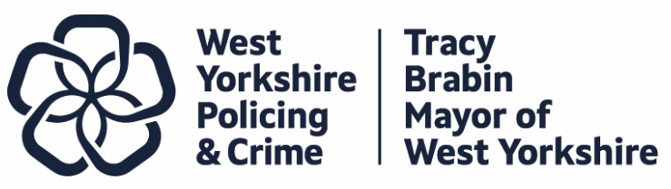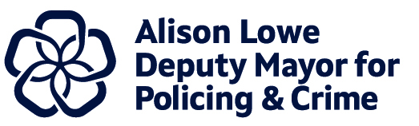

Report to: |  | Police and Crime Panel
Date: |  | 9th October 2026
Subject: |  | Precept Consultation – Introductory Paper
Report of: | Alison Lowe – Deputy Mayor for Policing and Crime
Author: | Policing and Crime Team

- PURPOSE OF THE REPORT
  - The purpose of this report is to provide members of the Police and Crime Panel with an update on planning for the precept consultation.
  - This report updates the Police and Crime Panel on the planning undertaken to date in preparation for the forthcoming consultation period.
- INFORMATION
  - The approach last year
    - The public consultation on the 2026/27 Council Tax police precept ran with the online survey between 19th December 2025 to 21st January 2026. The online survey closed on the 20th January, and the in-person consultation finished on the 21st January to maximise engagement opportunities. Like previous years, we waited until the precept cap was announced by the government before launching the survey so we could go to the public with an accurate picture of the costs associated with the proposed increase.
    - Residents were asked to share their views on the proposed £15 annual increase for Band D households, equivalent to 29 pence per week.
    - The consultation was widely promoted through targeted social media advertising to encourage responses from underrepresented groups, via the Combined Authority’s ‘Your Voice’ platform, and through our network of partners across West Yorkshire to broaden its reach.
    - 3,474 residents responded to the consultation. 2,562 of the responses were generated from the online survey and 912 came from in-person consultation.

  - Proposed approach for this year
    - As with previous precept consultations, we will continue to deliver an online survey, promoted through our own communication channels and partner networks. In addition, there is the option to utilise targeted paid social media advertising during the consultation period to increase engagement from underrepresented groups if required.
    - The online consultation will be launched following the Government’s announcement of the financial settlement and will include a closed question seeking residents’ views on the proposed council tax increase. Both the online and in-person consultation activities will include an optional open-ended question, enabling respondents to explain the reasons underpinning their views. A draft question set has been provided in appendix A.
    - All those taking part in the online and in person consultation will receive a clear and detailed cost breakdown outlining the charges applicable to their council tax band, along with an explanation of the rationale behind the increase in the police precept.

    - Our in-person work led by the Consultation and Engagement team will again target high footfall locations with diverse communities across West Yorkshire. The team will build on their previous work which includes piloting the question content ahead of the survey launch to inform the context of the consultation and the framing of the questions.
    - To reduce the risk of excluding individuals with limited digital access, the in-person consultation will be designed to engage with this group in addition to other underrepresented groups.
    - The objectives for the in-person consultation will include:
- Deeper engagement with a diverse group of residents, including under 35s and those who may be digitally excluded.
- Improved accessibility and greater equity in participation by offering consultation opportunities across a range of times, dates and locations.
- To measure support for the police precept options for 27/28.
- Obtain feedback on policing services, which will inform our work.
    - The team are preparing to increase the regular estimated 4-6 weeks in which to undertake the consultation and are aiming to start the in-person work before the Christmas break. However, this will be dependent on when the Police Funding settlement is announced. The consultation will remain open for as long as practicable to maximise engagement with our in-person opportunities running until 21 January 2027.
    - We have commissioned a trusted research partner, DJS Research, to deliver the survey alongside our in-house team. Using a mixed-method approach, the consultation will incorporate online, telephone and face-to-face engagement to maximise accessibility and participation. By utilising DJS Research as an additional resource, we aim to extend the reach of the consultation and engage a broader cross-section of residents by an estimated additional 1,000 responses. This approach will help ensure that individuals who are unable or less likely to participate online are still provided with an opportunity to share their views.
    - Some PCCs chose to launch their consultations before the Government settlement had been announced last year. However, feedback from previous focus groups indicated that respondents, whether participating online or in person, should be able to provide their views based on the actual financial impact rather than perceived implications. As such, it is important that the full financial context is made available as part of the consultation process.
    - With this in mind, the proposal for this year is to continue with a short online survey which shows if there is support for the proposed precept increase and the in-person work will provide the detail around the impact, thoughts and feelings of the proposal.
    - In developing the consultation approach, we are also considering the Panel precept commitment from last year to work with Panel members and relevant partners to start pre-engagement work before the official start of the consultation period. The Engagement Team will share a programme of engagement opportunities with the Panel in the winter. Panel members will also be invited to attend a pilot session, during which the consultation questions will be tested and refined prior to the launch of the survey.
- Conclusion
  - In conclusion, the precept consultation for the 2027/28 financial year is designed to engage a broad and diverse cross-section of residents through a combination of online and face-to-face consultation and engagement activities. This will be complemented by support from DJS Research, which will deliver a mixed-method approach incorporating online, telephone and in-person engagement to maximise participation and representation.
  - The consultation will launch once the government has announced the financial settlement, utlising a binary question to gauge support for the proposed tax increase. We will seek to understand the reasoning and rationale behind residents' answers by offering the option to answer an open question.
  - Like last year, residents will be offered a transparent cost breakdown of what costs they will incur based on their council tax band and reasoning as to why the police portion of council tax is being raised.
  - Building on the success of last year’s approach, the in-person consultation will once again be delivered at high-footfall locations across all five districts, ensuring engagement with a diverse range of residents. This approach will help maximise opportunities for participation among those who may be digitally excluded or who prefer to engage face-to-face. In addition, DJS Research’s mixed-method approach, incorporating online, telephone and in-person engagement, will further support accessibility and help ensure that the consultation is inclusive and representative of the region.
  - The Policing and Crime team and Deputy Mayor will endeavor to keep the consultation open as long as is feasible to ensure maximum engagement with residents.

Appendix A: Draft survey question set

- If you do pay Council Tax in West Yorkshire, what band is your property?
A
B
C
D
E
F
G
H
Don’t know
- Are you...
(Please tick all that apply)
A resident in West Yorkshire
A business owner in West Yorkshire
Someone who works in West Yorkshire
- Please indicate which district you live or own/rent a business premises in:
Bradford
Calderdale
Kirklees
Leeds
Wakefield
I don't live in West Yorkshire

- Do you support the proposal to increase the Council Tax police precept?
Yes
No

- Are there any comments or feedback you would like to make about the proposal?

- Do you have any other comments about funding the police service in West Yorkshire?

*This question set will be followed by a number of optional ‘about you’ questions such as age and ethnicity.

