Item 8
Police and Crime Plan Performance Measures – an overview
The below overview should be considered alongside the Performance Matrix which gives the detail for the individual measures of the Police and Crime Plan

Theme One – Serious Violence
Homicides have remained the same in West Yorkshire when comparing to the previous quarter, however, the number of homicides that are categorised as non-domestic and where the victim is under 25 has decreased slightly.
Knife crime has seen a slight decrease but generally a stable trend – which is the same for hospital admissions. Whilst West Yorkshire still has a high percentage of its knife crime which is linked to Knife enabled Robberies this is still lower than the England and Wales average – and continues to be lower for all the categories shown.
The latest data also shows that knife enabled robbery offences have fallen during the latest 12 months by 6.5% and demonstrates that efforts taken to tackle knife crime by the force are showing positive results.
Information on the new Serious Violence Strategy is included in the community measures section of this theme. We will keep this section updated with the latest information from the work towards the strategy going forward.
Theme Two – Confidence and Satisfaction
Overall confidence in the Police is currently on a slight increasing trend standing at 68.1%, although it is worth noting that this is slightly below the MSG average of 69.9%.
Similarly, West Yorkshire is still on an upward trend for regarding whether the police are doing a good or excellent job (48.0%). There has been a very slight decrease for those who agree that the police can be relied upon when needed (55.6%) but this is still the highest in the MSG. The question about whether the Police would treat you with respect has gone up slightly since the last quarter at 82.7% which stands above the MSG average of 81.7%. All other forces in our MSG group apart from South Wales have also seen an increase in relation to this metric over the last quarter.
The YouGov survey (chart below) asks if the police are doing a good job. The number of individuals who felt the police are doing a good job decreased slightly in the last quarter (down 1%) whilst the number of those who felt the police were doing a bad job increased slightly (up 1%). We have recently received the first wave of data from the Your Views survey and this will be included once we have higher numbers and thus more confidence in what it is showing.
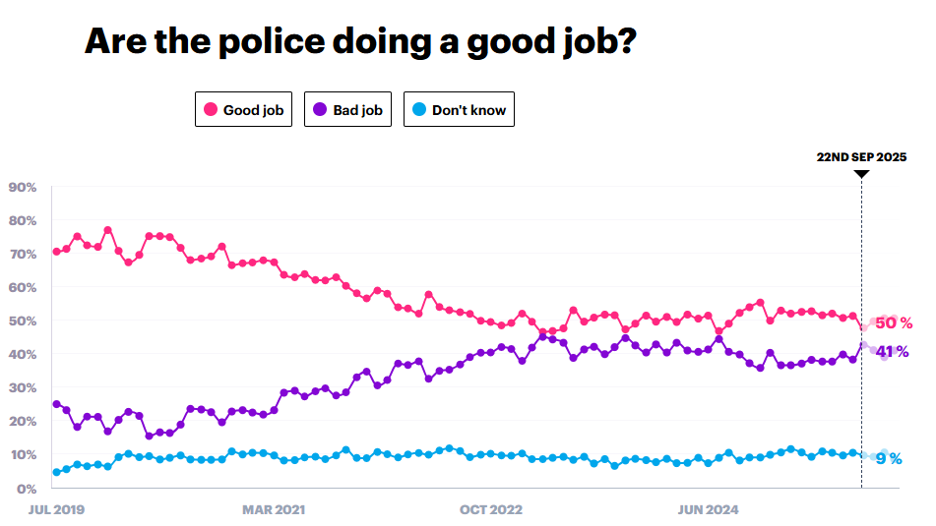
Theme Three - Crime and ASB
Total Crime is continuing on a steady decline, which, like we saw in the previous quarter, indicates that declines due to the recording crime changes are starting to lessen.
In 2019 WYP had a much higher crime rate than any of the MSG forces, but now this has changed and although still higher, is more in line with other forces (or rather other forces are getting in line with the excellent crime recording seen here).
Recorded ASB is higher than last year by 10.4%. To address and prevent antisocial behaviour (ASB), the government has introduced the Neighbourhood Guarantee. Several initiatives are expected to positively influence the forthcoming quarterly figures and beyond. The forthcoming ‘Winter of Action,’ co-ordinated by the Government and echoing the summer’s safer streets initiative, will target retail and street crime through a range of local authority-led measures designed to strengthen interventions in communities.
Theme Four – Supporting Victims and Vulnerable People
The number of Rape Offences continues to rise, alongside Stalking and Harassment and other Sexual Offences, resulting in a 24.1% increase in the last 12 months compared to the baseline. The month of July saw a particular spike in recorded rape offences but this seems to have levelled off and decreased in August and September. We will continue to monitor these numbers closely.
The number of missing children has seen a decrease during the last quarter, and we expect to see this trend continuing and levelling off into the colder months. We can see a similar trend regarding the volume of mental health incidents which had been on an increasing trend earlier this year but is now seeing a decline.
The community measures show the current picture for Child in Need and Child Protection. It is clear that the majority of cases are for emotional abuse and smaller numbers for physical and sexual abuse.
The measures from the Combatting Drugs Partnership show the numbers in treatment at the 31st March for different treatment regimes and the percentage of those that do not re-present after treatment. We can see that all trends are static, but for those being treated for Opiates, only around 5% do not re-present. This sort of drug use is shown to drive some of the offending that we see and is a concern.
Theme Five – Investigations
There has been a slight decrease in positive outcomes for Rape but the most recent month shows a slight upturn. There are good increases in the outcome rate for stalking and harassment, and other sexual offences. This continues to be an area of focus for the Women’s Safety Unit.
There has been a very slight increase in the number of domestic abuse crimes (up 2.6% compared to the same time last year), however the domestic abuse outcome rate is following a similar upward trend (up 0.2% from this time last year). Addressing Violence Against Women and Girls has been designated a Strategic Policing Requirement, and West Yorkshire is paving the way for this work.
The Clare’s Law Count is continuing to show a steady increase month on month. This is testimony to the success of the continued awareness campaign by the force to encourage residents to use the scheme and the numbers of DVPN and DVPO’s are also increasing.
The charts under community measures are from the Criminal Justice Dashboards for Adult Rape
They show the good work here to decrease the number of days taken for the police to charge an offender and how West Yorkshire has the smallest number of offences stopped due to victim not supporting the police action. But delays in court cases still leads to a high number of cases being dropped after the offender has been charged due to victim non-engagement. This is similar to other areas, but above national average.

Theme Six – Equity, Diversity, and Inclusion
The number of Stop and Searches during the most recent quarter has increased, however, the proportion of those having a positive outcome has stayed roughly the same standing at 33.8%.
There is still a disproportionate number of Stop and Searches regarding Black or Black British residents, and this is something being looked at as part of the various workstreams for the Police Race Action Plan. Significant progress is underway such as the rollout of the new traffic stop app that frontline officers use daily to help the force identify and better understand any disproportionality in how traffic stops are conducted. Over the past two years, the victim satisfaction rate for Black and Black heritage victims and crime has improved by 11.2%.
Regarding victim satisfaction there is a significant difference between overall satisfaction of White victims and for victims and callers from all other ethnic groups combined leading to a satisfaction gap of 5.5%, but this is a reduction compared to a year ago which stood at 6.5%.

Theme Seven – Vision Zero Measures
Provisional figures report that the number of fatal road collisions reported in the 12 months to September 2025 is 52 which is two more than 12 months ago. Collisions involving a serious injury have fallen by 76 in the past 12 months to 1,122 (down 6.3%) whilst 96 fewer slight collisions have been recorded (down 3.3% to 2,800).
The numbers of submissions to Op Snap are continuing on an increasing trend with 11% more than the same time period as last year, demonstrating the continued success of the campaign including increased awareness through comms activity. West Yorkshire Police issue 345,000 fixed penalty notices year and of those 18,000 are generated from Operation Snap owing to its success.
Additionally, the Camera Enforcement Unit enforces speed limits across the urban road and strategic road network on behalf of the West Yorkshire Safety Camera Partnership (WYSCP). The Camera Enforcement Unit uses a combination of mobile enforcement vans and fixed cameras at over 400 enforcement sites across the county. Using the latest average speed camera technology combined with ‘spot speed’ and red-light violation cameras the Unit detected 153,809 offences in the 6-month period from April to September 2025 (77,393 April to June, 76,416 July to September).
The Camera Enforcement Unit works closely with National Highways and uses a range of camera technology to enforce speed limits and ‘Red X’ lane infringements on the motorway network. There is long term enforcement activity on the managed motorway sections of the M1 and M62 and the Unit has detected a total of 14,502 offences on this network following camera activations during the period April to September 2025 (6405 April to June and 8097 July to September).

For more information contact
Wendy Stevens – Research and Performance Manager
wendy.stevens@westyorks-ca.gov.uk

Appendix 1 – P&CP – Performance Framework

