
Item 6

Report to: | Police and Crime Panel
Date: | 6 March 2026
Subject: | Road Safety and Vision Zero Update
Report of: | Alison Lowe, Deputy Mayor for Policing and Crime
Authors: | Neil Hudson – Policy Manager, Vision Zero  Phoebe Pitcher – Policy Assistant, Vision Zero

- PURPOSE OF THE REPORT

  - This paper is designed to give an overview of the current position in the county, the progress over the last period, and an understanding of the key challenges that have emerged regarding road safety.
  - The details of the report relate to the strategic priority of Safer Places and Thriving Communities within the 2024-2028 Police and Crime Plan. This priority focuses on the harmful and unacceptable behaviour affecting the different communities of West Yorkshire, through an ongoing commitment to neighbourhood policing and partnership working in localities. Work under this priority will tackle the place-based crime that damages people’s everyday lives, including anti-social behaviour (ASB), dangerous driving and speeding.
  - Road safety was one of the most frequently selected areas of focus during consultation under this priority, leading to the continuation of an effective Vision Zero approach across the districts of West Yorkshire. This sees us working towards eliminating all traffic deaths and serious injuries, while increasing safe, healthy, and equitable transport for all – partly through the leadership and scrutiny of the Vision Zero Board.
  - Vision Zero is a systems-based approach that maintains that no death or serious injury is acceptable on our roads. It accepts that road users are human and will make mistakes, so crashes may sometimes take place; to prevent those mistakes from resulting in fatal or serious injury, changes to the road environment are required to prevent people being exposed to forces beyond human tolerance levels. West Yorkshire has committed to achieving Vision Zero by 2040, with a 50% reduction in people killed and seriously injured by 2030, in line with UN road safety targets.

- INFORMATION
  - Since the initial commitment to a Vision Zero approach at the Roads Policing Convention in 2019, arrangements have been put in place to provide pan-West Yorkshire leadership for road safety, including the establishment of the Vision Zero Board. Chaired by the Deputy Mayor for Policing and Crime, this board provides political scrutiny and oversight of the work of the West Yorkshire Vision Zero Partnership (previously known as the Safe Roads Partnership) to ensure greater momentum and coordination. The first meeting of the Board took place in December 2021.
  - While West Yorkshire Police (WYP) are a key partner in this work, the Vision Zero ambition requires a holistic safe system approach, looking at all aspects of the road environment, including the roads, road user behaviour, speeds travelled, vehicles, and the post-collision response if a crash does occur. This means that the work spans more areas than policing alone, including, but not limited to highways and infrastructure, active travel, education, and public health. However, WYP continue to actively inform this work through data sharing and collaboration.
  - In WYP, ACC McCoubrey is the Chief Officer Team lead for Roads Policing, with Superintendent Brown holding the role of Superintendent Partnerships, Chief Inspector Farrar holding the role of Head of Roads Policing and Paul Jeffrey holding the role of head of Prosecutions and Casualty Reduction Unit. Each district policing area has a named SLT lead officer for Vision Zero at Chief Inspector level supported by a local Inspector who is accountable for operational activity contributing to Vision Zero at a local level and engagement with the local Vision Zero Partnership arrangements.
  - WYP have an appropriate representative at each level of the Vision Zero Partnership and are closely engaged with local road safety work. The links between the groups and their accountability structure are outlined below:
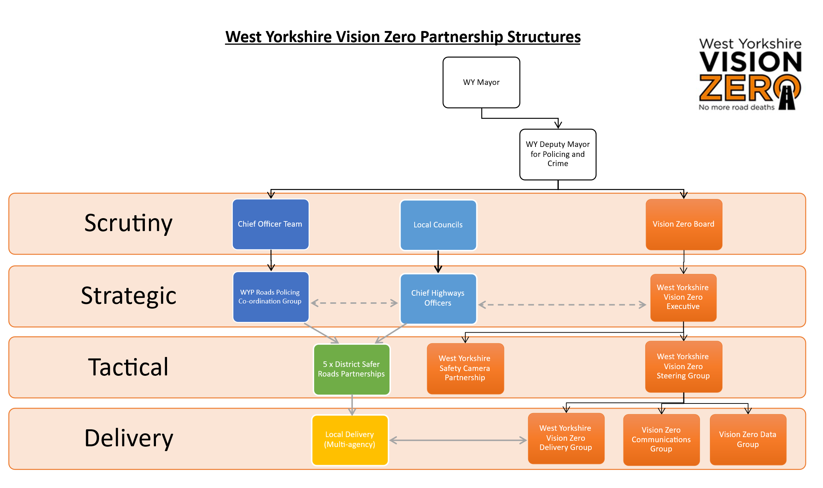
  - The WYP Roads Policing Co-ordination Group, which is attended by senior leads from each district alongside Vision Zero officers at WYCA, has continued to meet having been refreshed to bring focus to its work and provide opportunities to share best practice. Discussions at recent meetings have considered ways to improve partnership data around those involved in collisions, opportunities for additional roadside drug testing, and focus on district-based delivery of the West Yorkshire Roads Policing Strategy. This strategy reflects WYP’s continued ambition to deliver Vision Zero in collaboration with the Vision Zero Partnership and is structured around the safe system principles. This aligns with the approach that is taken in the Vision Zero Strategy for West Yorkshire.
  - The contents of the Vision Zero strategy have been influenced by collision data, our public consultation, ‘Safety on the Roads of West Yorkshire’, and engagement on partner organisations’ key priorities. WYP actively supported this development and presented at stakeholder consultation events on the role of policing in achieving Vision Zero objectives.
  - Casualties of Road Traffic Collisions in West Yorkshire
    - The main performance measure for road safety is the number of people killed or seriously injured (KSI) in road traffic collisions (RTCs) in West Yorkshire, which is included in the Police and Crime Plan performance measures. However, the West Yorkshire Vision Zero Partnership also considers the total number of casualties (including slight injury) as an indicator giving further context, as well as the number of deaths.
    - Of note, the figures for 2020 and 2021 for all categories of injury were impacted by the COVID-19 pandemic, during which time lockdown periods reduced traffic volumes across the country. Furthermore, in 2021 a new collision recording system (CRASH) was adopted in West Yorkshire, which has increased the accuracy of casualty severity recording. Officers are now able to select an injury type from a list, and the severity is assigned automatically. This has led to a net increase in reported injuries, alongside an increase in the proportion of injuries correctly recorded as serious, making comparisons to previous years difficult. Adjustments have been made to the below figures using the Department for Transport (DfT) algorithm to allow as close a comparison as possible.
    - Please note that for all three charts below that 2024 data the most recent currently verified by the DfT.
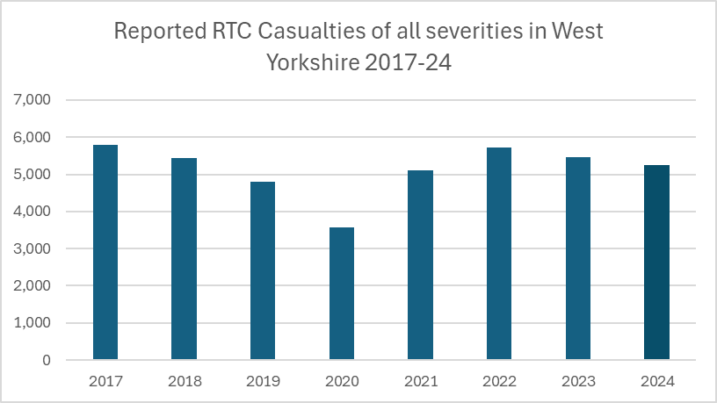

    - The overall trend for casualties of all severities shows an increase from pre-pandemic levels, with the number of people injured 9.7% higher in 2024 than 2019. However, there was a decrease between 2022 and 2023 and a further decrease between 2023 and 2024.

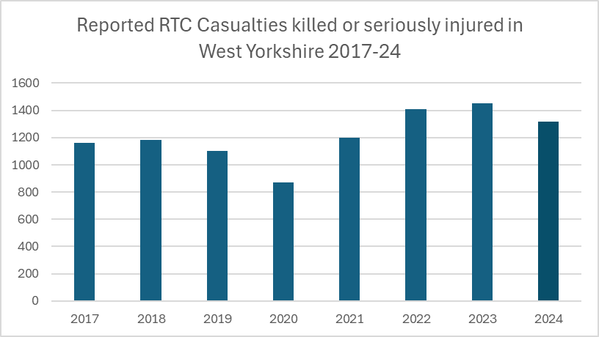

    - The number of people killed or seriously injured in road traffic collisions has increased since the pandemic. It is positive however that there were 9.3% less people killed or seriously injured in road traffic collisions in West Yorkshire in 2024 compared to 2023.

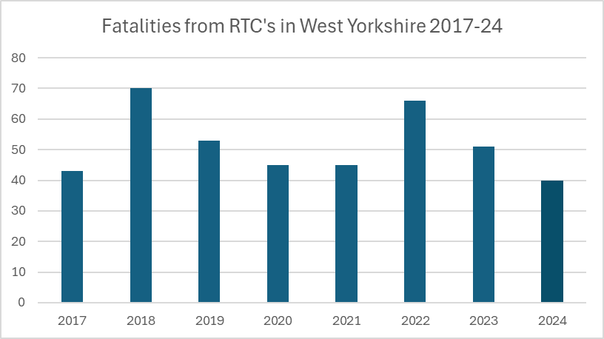

    - The number of people killed in 2024 was 21.6% lower than those killed in 2023, and 24.5% lower than the number killed in 2019. It should be noted that this verified data does show a more positive trend than previous reported to the panel. It should be noted that as these figures are much smaller, there can be large fluctuations year on year. Of note, provisional data for 2025 shows that the number of fatalities on our roads has increased. There was an increased number in the first few months of 2025 which was concerning and as a result Chief Inspector Farrar commissioned a piece of analytical work to identify any common factors, but this did not identify any consistent reason for the higher number of casualties at that time.
    - Previous papers to the Police and Crime Panel have detailed the number of KSI collisions in West Yorkshire as a key measure. However, this does not accurately represent our ambition to eradicate road deaths and serious injuries, as a single collision could result in multiple victims. It is recognized that all of the above figures represent people whose lives and families’ lives have been impacted by preventable death and serious injury. Alongside partners, WYP are engaged with work across the five safe system pillars to tackle danger on the road network and support victims in the aftermath of collisions.
  - Safe Roads
    - Work under the Safe Roads pillar generally relates to changes to the road environment such as road layouts, improvements to junctions, maintenance work, and providing better infrastructure for walking, wheeling, and cycling. Much of this work is the responsibility of the relevant highways’ authority; however, WYP are a key stakeholder informing this work. The Vision Zero Partnership introduced a Data Group meeting in April 2023 to help improve data sharing across organisations. As part of their work, an analyst at WYP has developed an automated monthly report of damage-only collision data to help inform highways teams of locations where no injuries have been reported, but where there may be risk. WYP have also developed a Power BI application to interrogate data, share location-based knowledge and provide additional tasking capabilities to the Vision Zero Partnership. WYP have also met with West Yorkshire Fire and Rescue and local council analysts to identify areas where joint use of data can inform future infrastructure interventions.
    - The use of data to inform practice is a key objective for all partnership working, and WYP are pursuing new aspects to provide the Data Group with. WYP put forward a successful case for their analysts to have direct access to CRASH and will be reviewing their tasking processes to maximise their effectiveness.
    - One of the current objectives for the five districts in the Vision Zero Partnership is to deliver school streets across the county. This involves the closure of key streets around schools during their opening and closing times to provide a low-traffic environment for students, which has created some local resourcing challenges for districts and their partners.
    - WYP has outlined the support available for school streets with neighbourhood police teams (NPTs) and facilitated better communication at the local level about where schools should report different offences (including for those that do not have a school street but see wider driving issues). While direct officer attendance is not a long-term solution to their management, this engagement does support the delivery of school streets while civil enforcement opportunities are developed.
  - Safe Speeds
    - Speed forms one of the ‘fatal five’ factors which frequently contribute to deaths from RTCs. Activity to tackle inappropriate speed overlaps with the Safe Roads and Safe Road Users pillars, and WYP play a significant role both through the work of local officers and, particularly, work with the West Yorkshire Safety Camera Partnership (WYSCP).
    - West Yorkshire Police Camera Enforcement Unit enforces speed limits and red-light violations using fixed and mobile safety cameras on behalf of the WYSCP.
    - The WYSCP Enforcement Unit detected 208,014 offences in the 9-month period from April to December 2025 (52,405 October to December). These offences were processed with eligible drivers undertaking retraining courses, receiving points and a fine, or appearing in court. These figures are in line with the 2024 previously provided to the panel.
    - In February 2023, the WYSCP adopted a new deployment strategy with the intention of promoting safe speeds across the entire road network and not just in the vicinity of enforcement cameras. It is now possible for enforcement to take place at locations where there is evidence of speeding but, crucially, no one has yet been killed or seriously injured. Under the new approach no additional signage warning of enforcement activity is required, provided all other legal requirements for signage are met. The deployment strategy has been shared with the Government Minister for Local Transport as good practice in the United Kingdom
    - The Partnership is continuing to deploy cameras to ‘high risk’ core sites where there is a history of low levels of speed limit compliance and collisions resulting in injury.
    - Since the launch of the new strategy a total of 467 potential new enforcement locations have been identified in direct response to concerns from local communities and following assessment these sites receive periodic enforcement activity using additional enforcement vehicles funded by the WYSCP. A total of 46,119 offences were detected at community concern sites during the period April to December 2025 (11,671 October to December). WYP have reported that the deployment of mobile enforcement vans in these locations has typically resulted in a reduced number of offences captured over time, suggesting the action taken has positively affected speed compliance.
    - The WYSCP has successfully installed West Yorkshire’s first average speed routes in 2023 in Leeds. These monitor speeds travelled along the whole route, rather than capturing driver behaviour at a fixed location. Where comparison data is held, offence captures have seen significant reductions compared to the period the previous year, suggesting these routes are successfully improving speed compliance. The West Yorkshire Vision Zero Partnership continues to consider average speed as a method of securing safer speeds across the county; of note, there are some ongoing challenges which partners are working to address, such as vandalism at new and existing camera sites. Further average speed routes have now been installed and in each case, we are seeing greater speed compliance.
  - Safe Road Users
    - Vision Zero maintains that there is a joint responsibility for all those involved in the road environment, including its users. This pillar aims to encourage safe behaviours of all road users through education, communication, and enforcement, where appropriate. WYP is currently involved in several local operations tackling high risk behaviour across the five districts, as well as supporting national campaigns coordinated by the NPCC.
    - The Roads Policing Unit manage and coordinate various proactive Force wide initiatives throughout the year, many of which are in line with the NPCC National Roads Partnership Operations calendar. One of the main operations each year remains the annual Christmas drink/drug drive campaign called Operation Limit. The RPU also lead and coordinate a range of operations including Fatal 5, Motorcycle, 2 Wheels, Pedestrians/Horse Riders, insurance, HGV and vehicle crime, immigration enforcement and several other multi agency operations.
    - Details of some examples of local operations tackling dangerous road behaviours are included below. While this reflects a range of positive activity, it is worth noting that road safety also forms part of officers’ routine work which is not included below. For example, WYP colleagues have recently reported increases in the number of offences captured by district officers in support of Vision Zero. This increase in road safety activity has been matched by increased capacity and efficiency in the central ticket office.

Operation Steerside
- Operation Steerside is the joint Bradford Council and West Yorkshire Police initiative targeting antisocial driving and vehicle-related nuisance. The operation utilises Public Spaces Protection Order powers alongside police traffic legislation to address dangerous driving, cruising, and vehicle-related ASB. Performance data and case outcomes are reported through the Vision Zero Bradford Delivery Group on a monthly basis. Op Steerside has supported a number of multi-agency events working with internal and external partners including DVLA, DVSA, council taxi licensing, CVET (Children Vulnerable to Exploitation Team) & Special Constables. Events have included support for Op Spittlemoor (Eid celebrations) and cross border patrols with Calderdale District.

Headline Figures: November 2024 – October 2025:
- 97 pre-planned operations
- 1785 Fixed Penalty Notices, Traffic Offence Reports & Vehicle Defect Notices
- 61 Reports to DVLA for no tax
- 274 Reports for Summons / Charged to Court
- 107 S.59 Warnings
- 271 Vehicles Seized
- 40 Arrests
- 22 PSPO breaches

Operation Hawmill
- Operation Hawmill is a partnership funded Road Safety operation, which aims to deploy twice a week into the district of Calderdale and has been in place for several years. Funding for this Operation has been once again secured from Calderdale Council in the current financial year.
- An RPU officer is crewed with a PCSO to deploy on the operation. The unit is deployed to a specific ward area, and briefed on the local priorities for that area, any road safety issues, or concerns of note. A road safety risk matrix has been completed to ensure that the resources are deployed to areas which present the greatest risk of KSI collisions and/or community concern.

Operation Amberland / Dedicated Off Road Bike Team
- Operation Amberland targets activity towards Hackney Carriages, Private Hire and Uber drivers. Whilst this activity is weighted towards road safety concerns, Leeds district recognises the opportunity to improve messaging and undertake reality testing in relation to safeguarding and VAWG concerns. The operation is supported by neighbourhood policing officers, the off-road bike team and local authority Taxi Licensing, and also forms part of regular NightSafeLeeds partnership operations during the night-time economy period.
- The Off-Road Bike Team has resulted in a reduction in motorcycle related ASB. The ‘Enough is Enough’ campaign, consisting of posters and leaflets given out on crime prevention days, is one example. These resources are given to offenders to explain the legalities of riding motorcycles and how people can report such behaviour to the police. The team continues to work with partner agencies such as housing, Leeds Anti-Social Behaviour Team (LASBT) and Leedswatch to target individuals and addresses of concern. PCSO’s aligned to the team are supporting work to tackle theft of and theft from motor-vehicle offences, especially those relating to motorcycles.

Operation Torrbank (Batley & Spen)
- Councillor funded speed reduction initiative.
- Problem locations identified by councillors are patrolled by Ops teams on overtime.
- Pro-laser enforcement and school visibility patrols carried out, supported by NPT engagement and education.

Operation Twinetre (Dewsbury)
- Councillor funded initiative tackling Fatal 5 behaviours.
- Patrols conducted as part of extended tours and daily tasking; overtime used to increase visibility.

The above two operations have now been merged to form KD – Operation Steerside.

Operation Teakshot / Operation Taskabbey

- Both are Off Road Bike related operations funded via Safer Streets. related operations funded via Safer Streets.
- Funding enables increased coverage, complementing daily NPT/ORB operational work.

The Off-Road Bike team
- Responds to ASB/ORB related logs
- Develops intelligence packages
- Conducts disruption visits
- Secures further funding
- Carries out environmental surveys
- Works with partners to prosecute persistent offenders and review hotspot locations

    - Proactive enforcement activity around illegal e bikes and e scooters continues, particularly in Leeds. Since September, officers have seized 89 bikes in the city. Officers have been deployed into pedestrianised areas, where they can stop riders and check e bikes being used in and around the city centre. Most of the seized bikes were being used for delivery work and were found to have no insurance and no licence, as they had been modified to increase speed and power. Following enquiries with manufacturers, officers have now obtained factory reset unlock codes, allowing them to fully inspect bikes and identify any adaptations made to circumvent legal limits. There is growing interest in conducting a test purchase operation relating to e bikes. Trading Standards have raised no objections and are happy to be involved, and further discussions are ongoing. As a result of continued enforcement activity, we are now seeing a reduction in the number of illegal e bikes in Leeds.

    - WYP have also supported regional and national campaigns, including those detailed below. WYP are also represented at the Vision Zero Communications Group, who will aim to amplify Vision Zero campaign outcomes and messaging to educate and deter potential offenders, with the support of the Vision Zero Communications Officer who has now been in post for over a year and sits within the West Yorkshire Combined Authority alongside policy colleagues.
October 2025 – NPCC Operation Dark Night
- NPCC National Roads Policing campaign between 27th Oct and 9th Nov 2025. The operation focused on highlighting and combatting the threat to vulnerable road users, in particular pedestrians and horse riders, during the winter months and darker nights. Several operations were conducted by RPU in relation to eyesight tests. This was complimented by a social media campaign, QR code for Officer’s to complete to aide with collating results and a power point

November 2025 – MIB Op Drive Insured (10th – 16th Nov) / BRAKE Road Safety Week (16th – 22nd Nov)
- Officers and staff from across West Yorkshire Police supported the Motor Insurer’s Bureau (MIB) led Operation Drive Insured, which targeted those drivers using motor vehicles without insurance. Roads Policing officers supported BRAKE Road Safety Week through the delivery of several educational inputs to hundreds of young people at local colleges across the force. This year the focus was on safer vehicles and to assist with this RPU ran operations in company with DVSA that focused on our powers to examine vehicles and in relation to Prohibition (PG9) of vehicles.

December 2025 – NPCC Operation Limit (1st Dec - 1st Jan)
- The Roads Policing Unit are leading on Operation Limit, the national annual campaign to target those who use our roads while under the influence of drink and/or drugs over the Christmas and New Year period.
- The Force refreshed its ‘12 Excuses of Christmas’ campaign, which was not only used to good effect last year, but was also highlighted as an example of good practice nationally by the National Police Chiefs’ Council (NPCC), who oversee the national drink and drug drive initiative.
- The force has also composed a new video incorporating an emotional excerpt from the family who’s loved one was killed by a drink driver within our County. This is designed to provide an impactful message of the consequences and effects of drink driving. This will be published on social media on the 1st December 2025.
- Static check sites will be set up across the Force throughout the campaign with the first one taking place on Monday 1st December where BBC and ITV will be attending. These will be run at different times throughout the day.
- A presentation has been completed and cascaded to all RPU Officer’s and promoted on the force homepage including the QR code to complete returns.
    - The NPCC have refreshed their national calendar of roads policing operations for 2026/27, and WYP will continue to support this. WYP are also involved in discussions at the national level encouraging the adoption of the fatal five, which would see careless and reckless driving recognised as a key risk alongside speeding, seatbelt noncompliance, mobile phone use, and drink/drug driving (the fatal four). In West Yorkshire careless and reckless driving factors continue to be recorded in over half of KSI collisions; it will be positive to see this prioritised nationally, as a number of other forces are also beginning to work to this.
    - A key action which was raised within the Vision Zero Partnership was the promotion of Operation SNAP, which allows members of the public to submit footage of dangerous driving to be processed by WYP. In response to public feedback, WYP now communicate details of Operation SNAP outcomes online.
    - Submissions for the period October to December 2025 have increased 2.4% compared to the same period the previous year (2457 compared to 2400) and 7.9% April to December compared to 2024 (8828 compared to 8182).

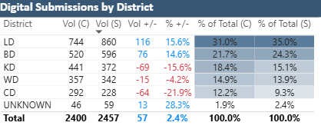

- 65.9% of all submissions have resulted in further action being taken following the initial assessment of the available evidence.
- 48.6% submissions resulted in the offer of a driver retraining course
- 16% resulted in a conditional offer of fixed penalty (points and a fine)

    - The importance of education and engagement as a preventative measure is recognised by all members of the Vision Zero Partnership. As part of their engagement with district road safety groups, WYP have supported educational delivery to students, such as multi-agency events during Road Safety Week in November 2025. At Vision Zero Partnership meetings, opportunities have been highlighted to further support local authority road safety education using Pol-Ed. The programme currently includes road safety lessons for both KS2 and post-16 settings. WYP education colleagues have attended partnership meetings directly to discuss how Pol-Ed works and allow local authority road safety teams to access the content with a view to ensuring consistency. WYP have reviewed attendance at the Partnership Delivery Group to ensure that they are best placed to support the ongoing education work.
  - Safe Vehicles
    - Work under the Safe Vehicles pillar aims to ensure that the vehicles on West Yorkshire’s roads are well-maintained and compliant with legal safety requirements. WYP play a role in educating the public about these standards as well as enforcing where appropriate, alongside partners such as the DVSA.
    - WYP recognise that there are often links between those using the roads dangerously and further criminality, which is outlined in the Strategic Policing Requirement (SPR). Roads’ policing has been included as a cross-cutting capability in the SPR as a result, requiring forces to ensure they have relevant technology, such as Automatic Number Plate Recognition (ANPR), the relevant skills and knowledge, and collaboration with agencies such as National Highways, the DVLA, and DVSA.
    - As mentioned above, a number of partnership operations have taken place which both address road safety issues and target criminals who use the roads to operate. Many activities incorporate intelligence from the ANPR unit to disrupt known criminals who use the road network.
    - WYP again secured support to match fund Operation Scalis, which delivered additional activity to tackle uninsured vehicles using £50,000 provided by the Motor Insurers Bureau (MIB). The MIB provide data to identify areas for deployment across the five districts, and this is combined with police intelligence.
    - WYP ANPR innovation and expertise was mentioned in the previous HMICFRS report and the innovation continues within the department with members in November 2024 being winners of the NPCC National ANPR Award for Innovation and also receiving a further highly commended award in Collaboration, and there are ongoing projects with both the Home Office, DSTL (Porton Down) and national suppliers on further new capabilities and opportunities to detect, deter and disrupt criminality of all types.
    - To support the promotion of Vision Zero, West Yorkshire Police have applied Vision Zero vehicle decals to approximately 600 vehicles in their fleet.
  - Post-collision Response
    - While the Vision Zero Partnership’s long-term ambition is that no one will be killed or seriously injured on West Yorkshire roads, the current position sees an unacceptable number of victims, families, and witnesses who will require support in the aftermath of crashes. This is especially the case in the context of significant wait times for criminal cases to go to court. Support is vital to help victims and families stay engaged with the criminal justice process and bring offenders to justice.
    - WYP currently provides support through Family Liaison Officers who have also referred bereaved families to Brake, the road safety charity. Brake operates the National Road Victim Service providing practical support and advocacy for victims, and last year once again received funding from West Yorkshire Vision Zero Partnership to support the work through a dedicated Independent Road Victim Advocate (IRVA). Between October 2025 and December 2025 (inclusive), Brake have supported 46 victims following crashes. 18 of these were new referrals across 13 cases. West Yorkshire Police have directly referred 15 of these which is 83% of the total – this is far above the 56% seen nationally.
    - Following discussions of post-collision support at the regional level, WYP have moved to an opt-out referral mechanism which has been seen to increase the proportion of victims receiving specialist support in other areas of the country. Family Liaison Officers and the Major Collision Enquiry Team (MCET) have been made aware of this, alongside RPU officers who also attend a large number of serious injury collisions. This is also a further reason for the increased support from Brake.
    - Alongside providing victim support, developing learning and communication following a collision is a key part of work under this pillar. WYP provide this through the investigative work of MCET and the Forensic Collision Investigation Unit (FCIU) in the aftermath of a collision. MCET have attended Vision Zero Steering Group meetings to explain their role in the process, challenges related to the judicial process, and potential opportunities for closer working. Since this time WYP have been reviewing their method of engaging with the districts following fatal collisions to improve efficiency.
    - Staffing resource to meet demands has previously posed a challenge for delivering post-collision outcomes, with a national shortage of forensic collision investigators, and the move for the FCIU hosted by WYP to cover the whole Yorkshire and the Humber Region. To meet these demands, as well as the requirements for accredited forensic collision investigative capabilities outlined in the SPR, the Yorkshire and the Humber FCIU created their own accredited course to address the workforce issues. This course has had a positive impact within the region and has also supported more broadly in other regions where staff have attended the training provide in our region.
    - The data and learning from collisions that do take place will be used to support the other four pillars of the safe system described above. WYP continue to advocate for more flexible and responsive use of data, including by challenging the constraints of DfT timescales for data validation.
  - Rates by district
    - At previous panel discussions around Road Safety and Vision Zero there have been requests to review rates of casualties for the 5 districts of West Yorkshire. The below tables are therefore provided to meet that request and they are based on the 2024 casualty data as verified by the DfT.
    - The below table shows the data used to calculate the rates:
 | Vehicle miles | Population
Bradford | 1,508,000,000 | 563,605
Calderdale | 972,000,000 | 210,929
Kirklees | 1,732,000,000 | 447,847
Leeds | 4,178,000,000 | 845,189
Wakefield | 1,904,000,000 | 367,666
West Yorkshire | 10,294,000,000 | 2,435,236

    - The vehicle miles data is taken from the DfT data tables for 2024, and the population data is taken from the Office of National Statistics 2024 mid-year estimates.
    - The below table shows the rates by district:

 |  | 2024 | Rate  (per 1000 Population) | Rate  (per million miles)
Bradford | Killed | 9 | 0.016 | 0.006
Calderdale | Killed | 3 | 0.014 | 0.003
Kirklees | Killed | 3 | 0.007 | 0.002
Leeds | Killed | 11 | 0.013 | 0.003
Wakefield | Killed | 14 | 0.038 | 0.007
West Yorkshire | Killed | 40 | 0.016 | 0.004
Bradford | KSI | 324 | 0.575 | 0.215
Calderdale | KSI | 135 | 0.640 | 0.139
Kirklees | KSI | 193 | 0.431 | 0.111
Leeds | KSI | 458 | 0.542 | 0.110
Wakefield | KSI | 208 | 0.566 | 0.109
West Yorkshire | KSI | 1318 | 0.541 | 0.128
Bradford | All severities | 1,345 | 2.386 | 0.892
Calderdale | All severities | 476 | 2.257 | 0.490
Kirklees | All severities | 783 | 1.748 | 0.452
Leeds | All severities | 1,893 | 2.240 | 0.453
Wakefield | All severities | 758 | 2.062 | 0.398
West Yorkshire | All severities | 5255 | 2.158 | 0.510

    - Of note within the data, it is clear that the rate linked to Wakefield in relation to fatalities is significantly higher than in other districts for 2024, but equally it should be noted that this figure was an anomaly as previous annual figures have been much lower for Wakefield. We did see the same with Calderdale in the previous panel report that has now significantly reduced again
    - Perhaps more of note within the figures is the significance of Bradford data linked to miles travelled. The KSI and all severities of injury data shows that the rate in Bradford is significantly higher than the West Yorkshire average. It should however be noted that in comparison to 2023 data the rate in Bradford for KSI’s has dropped from 0.253 in 2023 to 0.215 in 2024.
  - Motorway Data
    - Finally, the most recent 2024 DfT verified data shows that 45 people were killed or seriously injured on motorway roads in West Yorkshire, representing approximately 3% of all KSI casualties. Considering the very high traffic volumes and travel speeds on motorways, this indicates that they remain one of the comparatively safest parts of the road network.

- EQUALITY, DIVERSITY AND INCLUSION BENEFITS AND IMPLICATIONS
  - Vision Zero aims to create a safe road environment so that everyone in West Yorkshire has access to better mobility, regardless of how they choose to travel. This should bring health benefits for all residents in West Yorkshire as they are less exposed to harm, with additional benefits of access to work and education opportunities, and reduced transport-related social exclusion. Elements of the work, such as people-friendly transport planning and urban design, look to design infrastructure that addresses lack of provision for groups such as elderly, disabled, or child road users.

  - There is evidence to suggest that people living in more deprived areas are more likely to be injured in road traffic collisions. Groups from a lower socioeconomic background also have lower levels of car ownership, suggesting they may be less likely to cause harm to others while experiencing higher risk of injury. The Vision Zero Partnership is working to better understand and tackle these disparities, and WYP are reviewing opportunities to share more data.

- IMPLICATIONS FOR YOUNG PEOPLE IN WEST YORKSHIRE
  - Child casualties from road traffic collisions are considered as part of ongoing data analysis work for the West Yorkshire Vision Zero Partnership, finding an increasing trend since the COVID-19 pandemic.

  - The below chart shows reported Child Casualties in West Yorkshire:

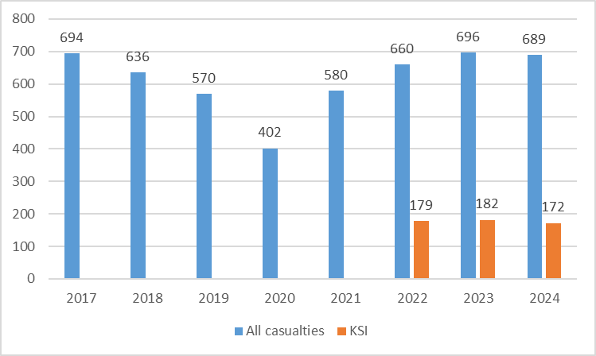

  - The below chart shows Child casualties by year of age in West Yorkshire for 2024:
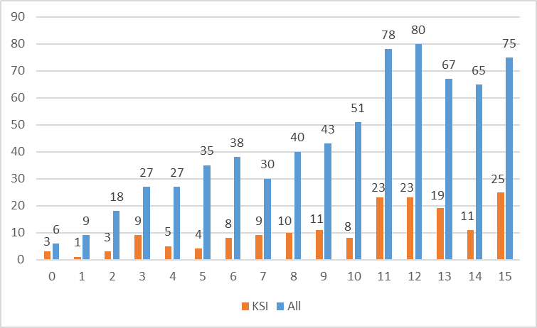

  - Action taken under all five pillars of the safe system approach aims to make the roads safer for children and young people, including in district road safety teams who deliver and commission education and training initiatives in West Yorkshire. This includes targeted sessions outside of educational settings for those at risk of vehicle-related offences, giving more practical inputs to meet different audience needs. The Mayor’s Safer Communities Fund also supports projects which divert young people away from dangerous behaviour, such as Bumpy (Birstall Urban Motor-Cycle Project for Youth) in Kirklees which provides on and off-road motorcyclist training while also raising awareness of the consequences of vehicular ASB and other dangers.

  - Young drivers are also a priority group at risk of involvement in road traffic collisions. The increased likelihood to young and inexperienced drivers (particularly male drivers) is seen nationally as well as at the West Yorkshire level. Rates of involvement in KSI collisions by age group are shown below:

Drivers/riders involved in all severity collisions, per 100,000 residents

Drivers/riders involved in KSI collisions, per 100,000 residents

  - As part of work to tackle this, the Vision Zero Delivery Group have commissioned a number of projects linked to children and young people.

  - The Partnership continues to support national communications campaigns aimed at young drivers and is considering opportunities to engage with national government about how to reduce risk for young people.

- FINANCIAL IMPLICATIONS
  - None.

- LEGAL IMPLICATIONS
  - None.

- EXTERNAL CONSULTATION
  - Where external consultation has taken place, this has been included in the paper and where possible public priorities have driven much of the ongoing work.

- RECOMMENDATIONS
  - That the panel note this report.

BACKGROUND PAPERS AND APPENDICES
None.

CONTACT INFORMATION

Contact Officer: | Neil Hudson
E-mail: | neil.hudson@westyorks-ca.gov.uk

