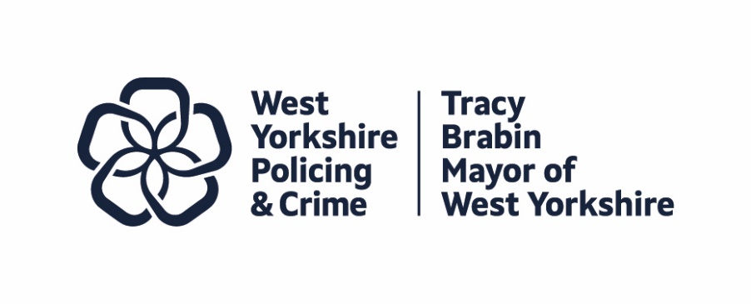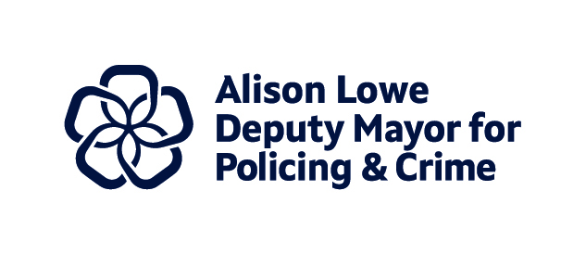
Item 6

Report to: | Police and Crime Panel
Date: | 13th December 2024
Subject: | Draft West Yorkshire Police and Crime Plan 2024-28 – Cover Paper
Report of: | Tracy Brabin – Mayor of West Yorkshire

- PURPOSE OF THE REPORT

  - The new draft West Yorkshire Police and Crime Plan 2024-28 is enclosed for the Police and Crime Panel’s consideration in line with the legislation detailed below.
  - Police and Crime Plans are a statutory requirement for all police force areas, introduced as part of the Police Reform and Social Responsibility Act 2011. The Plan is both a core planning tool for the Mayor and an important mechanism for communicating their intentions to the public, police, partners, the Police and Crime Panel and other stakeholders. Whilst the style and focus of each Plan is a matter for the elected Mayor, the Act identifies content that must be contained within it.
  - The Police and Crime Plan should determine, direct and communicate the Mayor’s priorities during their period in office and must set out for the period of issue:
- The Mayor’s police and crime objectives for the area
- The policing of the police area which the chief officer of police is to provide
- The financial and other resources which the Mayor is to provide to the chief officer of police
- The means by which the chief officer of police will report to the Mayor on the chief officer’s provision of policing and
- The means by which the chief officer of police’s performance in providing policing will be measured.
1.3 The Policing Protocol Order of 2023 states that the public accountability for the delivery and performance of the police service is placed into the hands of the PCC on behalf of their electorate. The PCC draws on their mandate to set and shape the strategic objectives of their force area in consultation with the Chief Constable. They are accountable to the electorate; the Chief Constable is accountable to their PCC. The Panel within each force area is empowered to maintain a regular check and balance on the performance of the PCC in that context.
1.4 With regard to the Police and Crime Plan, under this Order the PCC has the legal power and duty to:
- set the strategic direction and objectives of the force through the Police and Crime Plan (“the Plan”), which must have regard to the Strategic Policing Requirement set by the Home Secretary;
- scrutinise, support and challenge the overall performance of the force including against the priorities agreed within the Plan;
- provide the local link between the police and communities, working to translate the legitimate desires and aspirations of the public into action;
- PCCs and Chief Constables must have regard to the Strategic Policing Requirement and PCCs should take into account national policy when delivering their police and crime plans.
1.5 The Mayor is required to issue a new Police and Crime Plan as soon as practicable after taking office and, in doing so, should prepare a draft in consultation with the Chief Constable. The draft plan should then be sent to the Police and Crime Panel allowing a reasonable amount of time for it to be considered. The Mayor must have regard and provide a response to any report or recommendation made by the Panel. The Mayor must also publish that response and the Plan itself and send a copy of the Plan (or variation) to the Chief Constable.
- Journey of Development

  - Since the Mayor was elected in May 2024, the Police and Crime Panel have been given verbal updates on the Police and Crime Plan development including the opportunities available to engage in the consultation on the Plan.
  - Extensive work has taken place over the last six months to provide a solid evidence base for the new Plan. There are three key elements to this:
- The engagement and consultation with the public and partners in West Yorkshire through multiple methods, including online surveys, face to face events and focus groups.
- The production of a Needs Assessment document looking at the priorities in the previous Plan, with an analysis of any gaps and recommendations for the new Plan.
- The research and production of an Equality Impact Assessment (EqIA) in two stages.
  - As such, as well as the new draft Police and Crime Plan, the following documents are included for the Panel’s consideration:
    - Draft Needs Assessment Executive Summary. This document summarises the detail in the full Needs Assessment and includes recommendations. The Needs Assessment informs the Police and Crime Plan by reviewing the priorities and the cross-cutting themes within the Plan alongside the performance measures to discuss the successes (or otherwise) of the measures in the Mayor’s first Plan and to highlight any gaps with recommendations for the new Police and Crime Plan. It also takes into consideration the manifesto pledges of the Mayor for this new term and how they can be translated into action as part of the new plan
    - Performance Management Overview. This briefing document has been created to support Panel members to better understand the approach to performance management to date, and the proposed changes under the new Plan. The Performance Report has been agreed by both the Chief Constable and the Police and Crime Panel link member and informs the Performance Framework on the Police and Crime Plan.
    - Draft Equality Impact Assessment (EqIA) Stage 1 and Stage 2. The Stage 1 and Stage 2 EqIAs are working drafts, with initial sign off provided by the Head of Policing and Crime. Final versions will be published alongside the final Police and Crime Plan. The EqIA process requires the Stage 1 initial assessment followed by Stage 2 to undertake a more in-depth analysis of the impact on those with Protected Characteristics. Where these impacts are negative, it allows the opportunity to amend the scheme to mitigate these. Where the impact is positive, it allows the opportunity to identify the most pro-active ways to further Equity, Diversity and Inclusion duties.

- NEXT STEPS

  - Following this meeting, the Panel will provide a written report to the Mayor.
  - The Mayor will then consider the points raised and publish a response.
  - It is expected that the Mayor will finalise the Plan and publish this in early 2025, alongside final versions of key accompanying documents; the Needs Assessment, the EqIA, and the Voice of West Yorkshire.

- EQUALITY, DIVERSITY AND INCLUSION BENEFITS AND IMPLICATIONS

  - The Stage 1 and Stage 2 EqIAs are working drafts and are designed to support the Draft Police and Crime Plan at this stage. The templates used are the Combined Authority’s standard templates and initial sign off for the drafts has been sought and provided by the Head of Policing and Crime and the final versions will be published alongside the final Police and Crime Plan.
  - The EqIAs have been researched and drafted by a specific Equity, Diversity and Inclusion Working Group with members from both the Policing and Crime Team and Violence Reduction Partnership.
  - The EqIA process requires the Stage 1 initial assessment followed by Stage 2 to undertake a more in-depth analysis of the impact on those with Protected Characteristics. Where these impacts are negative, it allows the opportunity to amend the scheme to mitigate these. Where the impact is positive, it allows the opportunity to identify the most pro-active ways to further Equity, Diversity and Inclusion duties.
  - An essential element will be to monitor the impacts that the EqIA have highlighted and to evaluate whether the actions have been implemented and are effective. It is recommended that an EqIA review takes place every 12 months.

- IMPLICATIONS FOR YOUNG PEOPLE IN WEST YORKSHIRE

  - There are several implications for children and young people in West Yorkshire as part of this Plan.
  - The Police and Crime Plan must consider the Strategic Policing Requirements, of which one is child sexual abuse. This has been included in the draft Plan under Priority 1 – Keeping People Safe.
  - The central role of children is highlighted in the cross cutting theme of Children and Young People, alongside the commitment to the Child First lens.
  - Consultation took place with children and young people as part of the wider consultation work on the new Plan, including through some innovative approaches. Their feedback will form part of the Voice of West Yorkshire, which will be published alongside the Plan.

- FINANCIAL IMPLICATIONS

  - The Police and Crime Panel will continue to be updated on the Police and Crime budgets at the relevant times and how this aligns with the Police and Crime Plan.

- LEGAL IMPLICATIONS

  - The Police Reform and Social Responsibility Act 2011 and the Policing Protocol Order 2023 sets out the requirement for the Mayor to issue a Police and Crime Plan as soon as practicable after taking office and, in any case, before the end of the financial year (31st March) in which the Mayor is elected.
  - The Police and Crime Plan should determine, direct, and communicate the Mayor’s priorities for their local area during their period in office. This report updates the Police and Crime Panel on these priorities and provides:
- An update on the Mayor’s police and crime objectives for the area,
- An update on policing which the Chief Constable provides,
- One of the means by which the Chief Constable reports to the Mayor on the provision of policing, and,
- One of the means by which the Chief Constable’s performance in providing policing is measured.

- EXTERNAL CONSULTATION

  - The Panel have received an introductory paper on the scale of the consultation and the initial indicative findings.
  - The consultation on the new Plan with both the public and partners will form the Voice of West Yorkshire, which will accompany the Plan and provide the public’s view on police and crime priorities.
  - The key objectives for the consultation were:
- Ensure everyone can share and have their views heard on what should be included in the Police and Crime Plan
- Support understanding on the Mayor’s pledges, the spotlight on Serious Violence and draft priorities/themes/areas of focus
- Start the work to support the community co-design of the Serious Violence Strategy
- Ensure victims of crime and those impacted by crime are heard
- Raise awareness of the Mayors/Deputy Mayors role on Policing, Crime, and Community Safety including the strategies from the last plan
- Ensure all our engagement is fully inclusive.
  - The approach to the consultation reaffirmed the Mayor’s commitment to diverse responses and an inclusive process. The Voice of West Yorkshire will include diversity data relating to the consultation.

- RECOMMENDATIONS

  - That the Police and Crime Panel note this report and provide a response to the Mayor on the Police and Crime Plan for West Yorkshire.

BACKGROUND PAPERS AND APPENDICES

Appendix 1 – The draft Police and Crime Plan

Appendix 2 – The draft Needs Assessment Executive Summary

Appendix 3 – Police and Crime Plan Performance Management Overview

Appendix 4a – EqIA Stage 1
Appendix 4b – EqIA Stage 2

CONTACT INFORMATION

Contact Officer: | Wendy Stevens – Research and Performance Manager
E-mail: | Wendy.stevens@westyorks-ca.gov.uk

