Item 5 cont’d
Report to: | Police and Crime Panel
Date: | 17.04.26
Subject: | Police and Crime Plan Priority Two: Safer Places and Thriving Communities Performance Measures
Report of: | Alison Lowe, Deputy Mayor of West Yorkshire
Author: | Policy Team Policing and Crime – West Yorkshire Combined Authority

- Police and Crime Plan Performance Measures – Priority Two Overview (Safer Places and Thriving Communities).
  - The below overview should be considered alongside the Performance Matrix which gives the detail for the individual measures of the Police and Crime Plan. The summary below focuses on metrics relating to Priority Two in the Plan which is Safer Places and Thriving Communities.
  - The Performance matrix was developed in themes rather than linking performance measures to priorities, with the understanding that many performance measures span more than one priority. The below is therefore a look at the measures that mostly speak to priority two.

- Confidence and Satisfaction
2.1 Overall confidence in local police is the measure that is usually quoted from the Crime Survey of England and Wales (CSEW) data. For the first time since June 2024, we have risen above the Most Similar Group (MSG) average.
This seems to correlate to the next measure where since the pandemic the percentage of those who think the police are doing an excellent job in their local area has been below MSG average, apart from the last two quarters where we have now risen above MSG average and are now close to top for this measure.
The percentage of the public that agree that the police understand local concerns is level with the MSG average at 58.4%. However, the percentage of those who agree that the police and local council are dealing with the anti-social behaviour and crime issues that matter in the local area is below the MSG average at 43.3%, although this is currently on an upward trajectory.
2.2 The percentage of residents who feel that ASB is either a very big or fairly big problem in their area stands at 10.5% which is higher than the MSG average of 9.4%.
2.3 The latest victim satisfaction rate stands at 73.0% for the 12 months to December 2025. The latest position is a 0.6 percentage point reduction on the previous 12-month period, but this change is not statistically significant.
2.4 National context can be drawn from a recent YouGov article which was published on 30th March 2026 and looks at the public view of policing and crime in England and Wales. Amongst several statistics, they look at the satisfaction of victims and whether they are satisfied with the way their crime was dealt with. The below chart shows the areas of satisfaction broken down and they broadly follow the West Yorkshire pattern, with higher satisfaction rates for the treatment by the police and the response, but lower satisfaction with how the crime was handled.
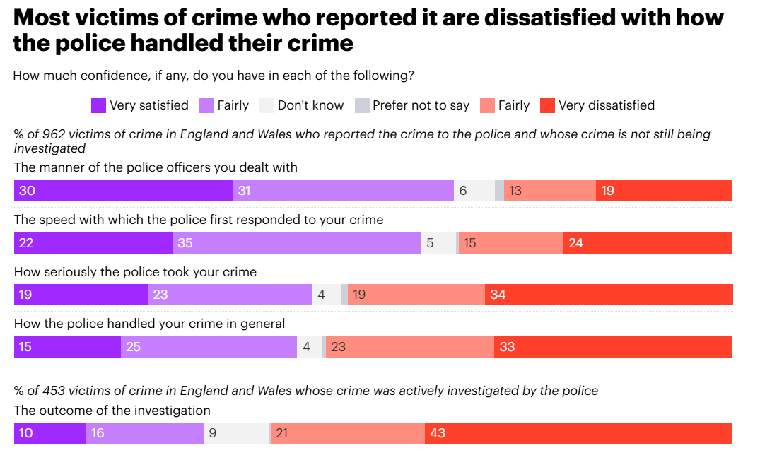
One interesting difference is that 60.3% in West Yorkshire were satisfied with the outcome of their investigation, whereas across England and Wales this is 26% according to YouGov.
*For context the YouGov poll was from 453 victims of crime in England and Wales whereas the West Yorkshire result is from 10,125 victims*
2.5 With regard to Response to Incidents, we find that West Yorkshire is currently on a reducing trend with emergency incidents at 81.8% (compared to 86.1% a year ago) and 68% of priority incidents compared with 85.7%.
West Yorkshire Police did have all domestic incidents classed as priority incidents and this increase in number is clear from February 2025, but due to the negative effect on response, this pilot was withdrawn and the decrease in numbers can be seen, so the drop in attendance rates has now stabilised and we expect this to rise in the future.

- Crimes and ASB
3.1 Total Crime is still on a reducing trend in West Yorkshire, and this trend is reflected in all our most similar forces. There have been some notable reductions in West Yorkshire, particularly business and commercial burglaries, public order, personal robbery, shoplifting, theft from person, violence with injury whilst stalking and harassment is also reducing.
3.2 Regarding neighbourhood crime, this figure is down by 33.6% when compared to the 2019 baseline which puts us mid table with comparison to our most similar forces.
Currently all types of neighbourhood crime are reducing in comparison to the previous year, and only one is currently above the 2019 baseline – this is Theft Of Motor Vehicle, which saw increases in 2021/22 but started on a reducing trend from April 2023 which continues.

3.3 Recorded ASB has fallen by 0.5% in the 12 months to December 2025 compared with the same period ending December 2024. Stalking and harassment offences have levelled off whilst arson, criminal damage and public order are all on a decreasing trend.
3.4 West Yorkshire Police (WYP) and partners have concluded the ‘Winter of Action’ initiative which was co-ordinated by the Government and echoed the summer’s safer streets initiative. This period saw a particular focus on retail and street crime through a range of local authority-led measures designed to strengthen interventions in communities. This action saw a 17% reduction in theft from shop and a 7% increase in arrest rate for compared to the same time last year. Additionally, there was a 26% reduction in robbery of personal property and a 7% increase in arrest rate, maintaining the same outcome rate. WYP also reported a huge increase in the use of ASB powers with 138 powers being used in the ‘Winter of Action’ compared to 35 powers used last year.

- Vision Zero Measures
4.1 Provisional figures report that the number of fatal road collisions reported in the 12 months to December 2025 is 51 which is ten more than 12 months ago. Collisions involving a serious injury have fallen by 70 in the past 12 months to 1,100 (down 6.0%) whilst 133 fewer slight collisions have been recorded (down 4.6% to 2,749).
Regarding Operation SNAP (the service provided to the public to facilitate the uploading of digital media footage e.g. Dashcam clips), submissions for the period October to December 2025 have increased 2.4% compared to the same period the previous year (2457 compared to 2400) and 7.9% April to December compared to 2024 (8828 compared to 8182). 65.9% of all submissions have resulted in further action being taken following the initial assessment of the available evidence and 48.6% submissions resulted in the offer of a driver retraining course. 16% resulted in a conditional offer of fixed penalty (points and a fine).
(more detail on Operation Snap is contained in the Road Safety paper that accompanies this paper)

For more information contact
Wendy Stevens – Research and Performance Manager
wendy.stevens@westyorks-ca.gov.uk

Appendix 1 – P&CP – Performance Framework

