Item 6
Police and Crime Plan Performance Measures – an overview
The below overview should be considered alongside the Performance Matrix which gives the detail for the individual measures of the Police and Crime Plan

Theme One – Serious Violence
Homicides have increased slightly in West Yorkshire. However, in terms of offences per mil population, we are again below Greater Manchester, South Yorkshire and the West Midlands.
Knife crime has seen a slight decrease – and this is reflected in the hospital admissions data also. Whilst West Yorkshire still has a high percentage of its knife crime which is linked to Knife enabled Robberies, this is still lower than the England and Wales average – and continues to be lower for all the categories shown.
The latest data also shows that knife enabled robbery offences have fallen during the latest 12 months by 6.4% and demonstrates that efforts taken to tackle knife crime by the force are showing positive results.
Information on the new Serious Violence Strategy is included in the community measures section of this theme. We will keep this section updated with the latest information from the work towards the strategy going forward.
Theme Two – Confidence and Satisfaction
Overall confidence in the Police is currently on a slight increasing trend standing at 67.4%, although it is worth noting that this is slightly below the MSG average of 69.1%.
Similarly, West Yorkshire is still on an upward trend for regarding whether the police are doing a good or excellent job (46.7%) and there has also been a very slight increase for those who agree the police can be relied upon when needed (56.3%) and highest in the MSG. The question about whether the Police would treat you with respect is also on an upward trend for West Yorkshire at 82.2% which stands above the MSG average of 80.5%. All other forces in our MSG group have also seen an increase in relation to this metric over the last quarter.
The YouGov survey which asks if the police are doing a good job. The number of individuals who felt the police are doing a good job decreased slightly in the last quarter whilst the number of those who felt the police were doing a bad job increased slightly. However, overall, the picture shows a level trend since the beginning of 2025 and once we have the new ‘Your Views’ survey in place this will help us with a greater understanding of these measures at a local level.
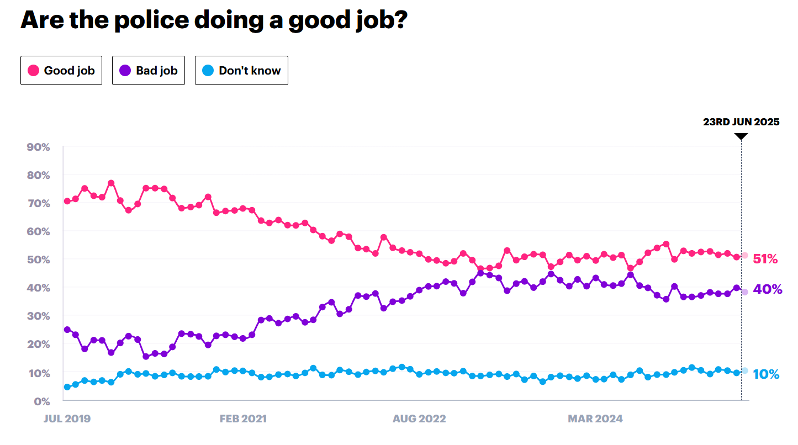
Theme Three - Crime and ASB
Total Crime is starting to level out, which, like we saw in the previous quarter, indicates that declines due to the recording crime changes are starting to lessen.
In 2019 WYP had a much higher crime rate than any of the MSG forces, but now this has changed and although still higher, is more in line with other forces (or rather other forces are getting in line with the excellent crime recording seen here).
Recorded ASB is slightly higher than last year by 2.8%. To address and prevent antisocial behaviour (ASB), the government has introduced the Neighbourhood Guarantee. Several initiatives are expected to positively influence the forthcoming quarterly figures and beyond. These include the appointment of a dedicated ASB lead officer and the launch of a Neighbourhood Policing Week of Action, which commenced on 23 June.
In the Community Measures you can find the early results from the Government’s Safer Streets initiative. This highlights arrests made for retail crime and street crime but also includes a variety of initiatives conducted by local authorities to support the interventions in the area.
Theme Four – Supporting Victims and Vulnerable People
The number of Rape Offences continues to rise, in addition to domestic occurrences increasing slightly this quarter. Regarding stalking and harassment offences, during the last quarter we can see that harassment was the most commonly recorded offence making up 60.6%, followed by stalking at 22.0%.
The number of missing children has seen an increase during the last quarter, which can sometimes be expected due to warmer weather. However, numbers have decreased in June and we expect to see a levelling off in the next few months.
When looking at the community measures we can see that there is a well-established statistical association between school exclusion and involvement in crime, with excluded young people being at a significantly higher risk of police-recorded violence and self-reported violent behaviour compared to their peers. After big increases since the pandemic there has been a recent levelling off and a decrease in the number of total persistent absences. This data is looked at in detail by the Violence Reduction Partnership (VRP) as part of their needs assessment.
Many of the measures from the National Combatting Drugs Outcomes framework is not available at either local level or in the public domain. There are a number of measures that are used by our local Combatting Drugs Partnerships which are available for us, and we will build our compendium of these in the coming quarters.
Theme Five – Investigations
There has been a slight increase in positive outcomes for Rape although as with other areas of the country this is still far too low. There is a slight decrease in the outcome rate for stalking and harassment, and other sexual offences. This will be an area of continued focus for the Women’s Safety Unit.
It’s worth noting that when looking at the Criminal Justice System delivery data dashboard for adult rape, the Force tracks as a national leader regarding how many cases it refers to CPS, with 6% of the total national submissions.
There has been a levelling out of domestic abuse crimes and domestic abuse outcome rates since the start of the year however the most recent figures indicate a very slight increase in crimes. Addressing Violence Against Women and Girls has been designated a Strategic Policing Requirement, and West Yorkshire is paving the way for this work.
The Clare’s Law Count is continuing to show a steady increase month on month. This is testimony to the success of the continued awareness campaign by the force to encourage residents to use the scheme. Although there has been a slight reduction in the number of DVPNs issued, the overall trend remains stable.
The chart under community measures which shows the average days taken for police to charge an offender in victim-based cases shows that in 2023 West Yorkshire was taking the longest of all the similar areas to charge and offender, but this has improved massively and by Q1 2025 was 40% below this high level. This trend has stabilised in the last quarter and is now below the national average.
One of the areas where West Yorkshire does well is with regard to the retention of victims. This chart shows the percentage of victims who no longer support the prosecution on the day of trial and for West Yorkshire this is currently at 1.2% compared with 4.3% in South Yorkshire and 2.3% in Greater Manchester.
One of the areas where West Yorkshire struggles is in the early guilty plea rate. This has been a problem that the LCJB is grappling with and looking at the data from the various courts to understand why this is the case. Although we are worst in comparison to similar areas for this measure, the best is only 9% points higher, and so can change easily.
Theme Six – Equity, Diversity, and Inclusion
The number of Stop and Searches during the most recent quarter has slightly decreased, however, the proportion of those having a positive outcome has stayed roughly the same standing at 33.9%.
There is still a disproportionate number of Stop and Searches regarding Black or Black British residents, and this is something being looked at as part of the various workstreams for the Police Race Action Plan. For example, the use of the QR code to receive feedback on how officers conduct stop and search allows Local Policing to tailor training where it is required specifically to each district’s needs. To date the Force have received over 100 submissions to the feedback portal from people who have been subject to stop and search.
Regarding victim satisfaction there is a significant difference between overall satisfaction of White victims and for victims and callers from all other ethnic groups combined leading to a satisfaction gap of 5.5%, but this is a reduction compared to a year ago which stood at 6.0%.
Theme Seven – Vision Zero Measures
Like the previous quarter, the Vision Zero measures are showing a slight increase in fatal collisions. This is mostly due to an increase at the beginning of the calendar year but the decreasing trend for serious injury offsets this and there is also a decreasing trend for slight injury meaning the overall trend is moving in the right direction.
Some of the other data sets for this theme are not currently available and will be built up as part of iterations of this document.
The numbers of submissions to Op Snap are continuing on an increasing trend with 9% more than the same time period as last year, demonstrating the continued success of the campaign including increased awareness through comms activity.
Additionally, the Camera Enforcement Unit works closely with National Highways and uses a range of camera technology to enforce speed limits and ‘Red X’ lane infringements on the motorway network. There is long term enforcement activity on the managed motorway sections of the M1 and M62 and a total of 6405 offences have been detected following camera activations during the last quarter.

For more information contact
Wendy Stevens – Research and Performance Manager
wendy.stevens@westyorks-ca.gov.uk

Appendix 1 – P&CP – Performance Framework

