Item 7

WEST YORKSHIRE POLICE AND CRIME PANEL

7 NOVEMBER 2014

UPDATE ON THE PARTNERSHIP EXECUTIVE GROUP

Introduction

- During transitional work undertaken by the West Yorkshire Police Authority (WYPA), prior to the first Police and Crime Commissioner (PCC) elections in November 2012, it was recognised it would be vital for the PCC to work in partnership with others to cut crime and promote community safety and that the PCC would need to work with community safety partners, criminal justice agencies and the voluntary sector to help deliver what was important locally.
- At the meeting held on 25 September 2012 members of the Transition Board wished to propose to the PCC that the group continued to meet, with the acknowledgement that current members of the Police Authority would no longer be involved and the group be renamed the Partnership Executive Group (PEG).

- A decision paper was produced in conjunction with the WYPA PCP and Partnerships Project Group and the WYPA Transition Board which made the below additional recommendations to the elected PCC:

- Chief Executives from all five local authorities are invited to become members of the proposed Partnership Executive Group.

- That an early decision of the Partnership Executive Group is discussion on whether a practitioner partnership group be established.

- The Partnership Executive Group establish a working relationship with the five Health and Wellbeing Boards.

The PCC agreed to this proposal and has since extended the membership to include a wider range of partners. Meetings are held on a quarterly basis at the OPCC offices.

- Membership includes representatives from Public Health, West Yorkshire Police, West Yorkshire Police and Crime Panel, Crown Prosecution Service, West Yorkshire Fire and Rescue, Third Sector, Prisons, National Probation Service and Community Rehabilitation Company. (A full list and the terms of reference are attached as Appendix A).

Structure and Terms of Reference

- The group has the following terms of reference:

- Through a shared ambition establish how through working together we can identify solutions that work in West Yorkshire to reducing crime and disorder, improving community safety and criminal justice service effectiveness and efficiency.

- With a focus on what matters to our communities identify where the impact of change through opportunities to problem solve, influence, innovate and galvanise partnership responses to crime, disorder, community safety and criminal justice are realised.

- To go beyond partnership reciprocal duties as defined by current legislation to share the delivery of the Police and Crime Plan during times of reduced resources to ensure West Yorkshire Communities are safe and feel safe.
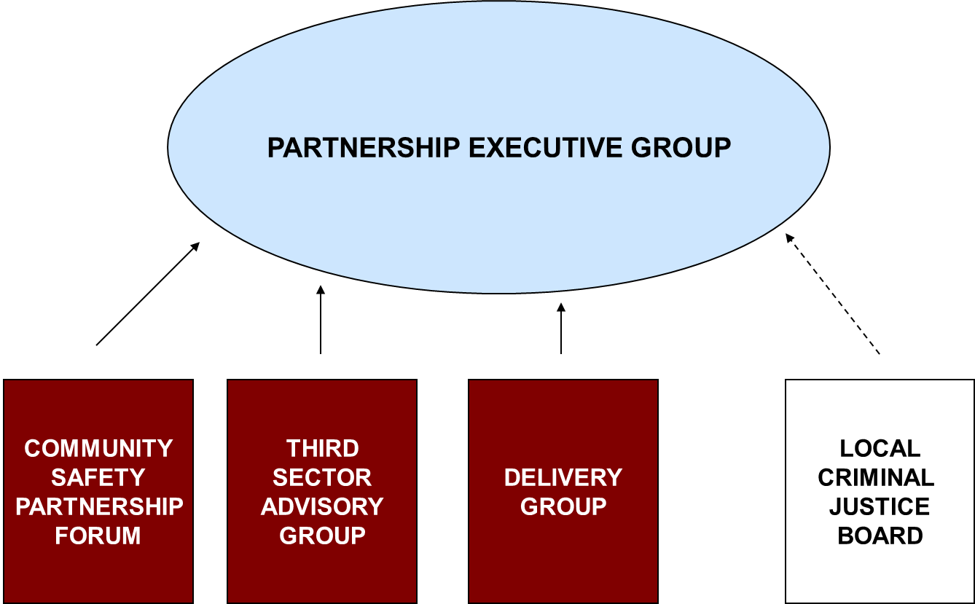

Areas of Work

- The group has been responsible for holding a wide range of discussions, providing updates and contributing to a number of projects and decisions.

These decisions have included:

- Creation of the West Yorkshire Community Safety Partnership Forum

- Public Health Registrar Secondment
Suggested by a current PEG member and agreed by the group. Adjusted secondment terms so that focus would be on Mental Health and that regular updates would be given at PEG meetings. Tasked with establishing a Mental Health lead group to steer work, supported by the Deputy PCC.

- Innovation Fund
The Police and Crime Commissioner for West Yorkshire, Mark Burn-Williamson has allocated a £1m budget over the next two years (£500k for years 2014/15 and £500k for 2015/16) to assist the Partnership Executive Group. Members made the decision to establish a sub group to explore opportunities to innovate and galvanise partnership responses to crime, disorder, community safety and criminal justice and report back. Aim of the group is to define and propose key themes and approaches to the Partnership Executive Group. Group have met twice with a further meeting planned for November.

- In addition the Partnership Executive Group have provided regular contributions to the Police and Crime Plan, supported and advised the Office of the Police and Crime Commissioner and had oversight and commented on for example the ‘Feeling Safe survey distributed to approx. 30,000 households in October. Members receive regular updates and comment on the Third Sector Advisory Group, Delivery Group, West Yorkshire Community Safety Partnership Forum, commissioning activity, victim support services and other funding streams. (Minutes for 2014 meetings are attached as Appendix B).

Future work will look at developing a forward agenda plan for the 2015 meetings, working more closely with the Local Criminal Justice Board and facilitating relations between partners and the OPCC WyFi team.

