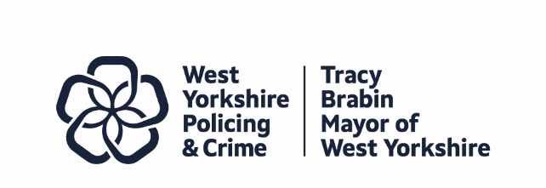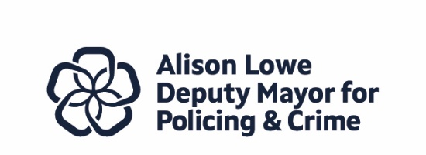
Report to: | Police and Crime Panel
Date: | 17th July 2026
Subject: | PEEL Inspection of West Yorkshire Police
Report of: | Tracy Brabin, Mayor of West Yorkshire
Author: | Wendy Stevens – Research and Performance Manager

- PURPOSE OF THE REPORT

  - This report is to give an overview of the PEEL (Police Efficiency, Effectiveness and Legitimacy) inspection of West Yorkshire Police
  - The full report is published on the HMICFRS (His Majesty’s Inspectorate of Constabulary, Fire and Rescue Services) website. The link to the full report is here - PEEL 2025–27: An inspection of West Yorkshire Police - His Majesty’s Inspectorate of Constabulary and Fire & Rescue Services.
- INFORMATION

  - The PEEL inspection programme is HMICFRS’s regular assessment of the effectiveness, efficiency and legitimacy of police forces in England and Wales.
  - West Yorkshire Police was one of the last forces inspected in the 2023-25 inspection round and one of the first in the new 2025-27 cycle.
  - As a result of the changes made to the PEEL inspection after the 2023-25 round, the results are not comparable. For more information on what has changed for this inspection, please see the update on the HMICFRS website - PEEL assessments 2025-2027 –
  - Below is a synopsis of the full report, focusing on the Areas for Improvement and some of the main findings for each area inspected.
  - As part of the Mayor’s Scrutiny function of the police, there is a statutory duty to publish our response within 56 days outlining how the force will address the PEEL recommendations which will be published on our website. The Mayor and Deputy Mayor are holding regular meetings with WYP to discuss the recommendations and ensure force-wide improvements are being made.

2.5 Overall Judgement
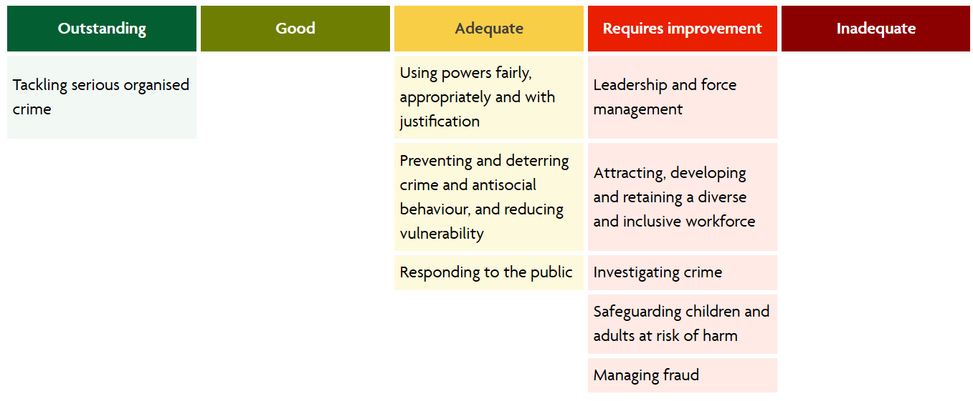
* Crime Data Integrity
* inspected in 2024 but not updated in this PEEL inspection.

2.6 Leadership and force management

Areas for improvement
1 The force needs to make sure that governance arrangements appropriately identify and resolve areas of risk and underperformance
The force was praised for changes since the last inspection, but the inspectors felt they ‘still’ are not good at detecting areas of risk
- The force needs to demonstrate how it understands and addresses the impact of change on its workforce
Officers and staff felt that senior leaders were remote from them so there was a disconnect which was reinforced by the workforce survey.
- The force needs to make sure that its operating model can address current and future demand.
At the last inspection, the force was told they need to get better at managing demand – the inspection noted that the force had improved its access to data, but there were still teams with high workloads or skills shortfalls.

2.6.2 Main Findings
The main findings for this area were that the force planning with FMS was good but needed to be used more but the priority-based budgeting process had matured.
The use of predictive analytics for demand was good, but the force was encouraged to use more real time data along with reviewing this against resource allocation
Intelligence gathering is good in force, but problems with consistency and application needed to be reviewed to ensure it does not impede collection and analysis.
Performance data was improving – this was an AFI at the last inspection, and the use of PowerBi dashboards was encouraged, but some inconsistencies were found and limited partner data was included. The force was encouraged to improve the range and quality of the data.
The training of its leaders was praised, and most officers felt that their manager displayed leadership qualities, but less felt this was displayed by senior leaders, so the force needed to understand how leadership behaviours are perceived by the workforce.
The digital transformation was evident, but the force lacked a digital, data and technology strategy.
The force showed how it linked the finances to the priorities, and it was commented that the use of reserves was sensible and the general reserves were adequate.

2.7 Attracting, developing and retaining the workforce and creating a diverse and inclusive workplace

2.7.1 Areas for improvement
- The force needs to make sure that effective systems are in place to monitor workloads and provide support to officers
In the last inspection this was flagged and some progress has been made, but still, some have unmanageable workloads so remains an area for improvement.
- The force needs to make sure that it creates an inclusive culture where staff feel a sense of belonging and are able to speak out
The force’s equality, diversity and inclusion strategy had limited content and no updates. The cultural awareness training was mentioned, and the force was praised for its misogyny survey. Staff stated thy struggled to access equipment, but the force has responded quickly to this
- The force needs to improve the training and support it provides for trainee investigators
This looks at the numbers who have received PIP training and highlights that this is lacking in specialist departments. Officers said they did not feel supported, but it was acknowledged that this was changing.
- The force should review the processes and procedures in place in relation to officers in high-risk roles who are identified as requiring additional support to make sure that appropriate action and support is in place
This was an AFI from the last inspection and although progress has been made it was still felt this needed focus
- The force should make sure that it has an effective occupational health unit with suitably trained staff, and reduce the time from referral to appointment
The waiting time for occupational health was noted at the last inspection, and the force have completed a review – they bought the time down by bringing in agency staff, but this is not sustainable, so HMICFRS wants the force to implement the finding from the review

2.7.2 Main Findings
The number of officers that have received specialist training for Neighbourhood Policing roles was mentioned.
The significant progress with the Professional Development Reviews was discussed with officers and staff stating it was easier to use – but although learning and development objectives were included in all officer reviews, this was not the case for staff and something that the force recognises.
With regard to positive action – some expressed concern this could be seen a positive discrimination – and was something the force needed to clearly communicate.
The training schedule was mentioned as it was not the same for all, and this is something that the force is looking into.
The talent management tool was mentioned – and seen by some as causing tension so this needs to be evaluated.
The stay & exit interviews were discussed – there was no meaningful data from exit interviews and the criteria of stay interviews was discussed. The force acknowledges this area needs to improve.

2.8 Using powers fairly, appropriately and with justification

2.8.1 Areas for improvement
- The force needs to make sure all officers have up-to-date public and personal safety training (PPST) and that it has consistent processes in place to identify officers whose training has expired
The force has been deploying officers whose PPST training had expired – with supervisors not having access to the data they need
- The force should provide training for officers on how to safeguard children involved in stop and search or use of force incidents
Not all officers understood the need for a safeguarding referral for certain incidents – in West Yorkshire this was via a Public Protection Notice referral. HMICFRS viewed 5 use of force incidents with children, and in all 5 no PPN referral was made.
Innovative Practice
The force supported the creation of an innovative community group to improve its relationship with the Black community
The force supported the launch of community group Scrutiny for Police Action on Race in Kirklees (SPARK). The group aims to improve community and police relations in line with the Police Race Action Plan.

2.8.2 Main Findings
The inspection found that the force consistently used Body worn video (BWV) and equipment problems would be rectified by the end of May by a new BWV rollout.
The force supports independent scrutiny and the panels witnessed were well managed.
Stop and Searches were scrutinised with an increased percentage (96.3%) showing reasonable grounds. There was good data recorded with only 3% not including self-defined ethnicity in comparison to 18% across England and Wales. The conclusion was that the force makes good use of Stop and Search.
It was concluded that the force does not record enough use of force incidents – these have decreased by 6.2% and it is thought this is due to under recording, not a decrease. The force needs to make sure officers are accurately recording use of force.

2.9 Preventing and deterring crime and antisocial behaviour, and reducing vulnerability

2.9.1 Areas for Improvement
- The force should make sure its leadership and governance processes support a consistent approach to prevention activity
This was with regard to the Neighbourhood Policing teams - The force should strengthen its governance processes and focus on establishing effective performance measures.
- The force should do more to develop, quality assure and evaluate its problem-solving activity
This was an AFI in the last inspection and although there were good improvements seen the number was considered low and needed to develop a culture of problem solving more widely
Innovative Practice
The Junior Detectives programme in Leeds was seen as an impressive to help educate young people and raise awareness.

2.9.2 Main Findings
The force understands the causes of anti-social behaviour and vulnerability in communities but is not consistently working with partners to use preventative and/or protective orders. The lack of a dedicated team in Leeds found that problem solving work in the district was limited. Officers across the force were using ASB legislation, and were most confident to use it, apart from in Leeds since the dedicated team was disbanded.
There was not consistent communication with the communities in West Yorkshire and officers were not using the force engagement tracker, so the force was unable to quantify what work had been completed. It has recently started Op Impact to improve this. It was concluded that the force had made improvements but there is still work to do.
The force was previously unable to monitor the abstractions of Neighbourhood officers, but it had invested in the Neighbourhood teams
Although the force has Integrated Offender Managers, there was need for stronger supervisory oversight and governance processes.
There was also a need for more governance of the Early Action Teams and ensure there was enough capacity in the team.

2.10 Responding to the public

2.10.1 Areas for Improvement
- The force needs to attend calls for service in line with its published attendance times, update callers about delays and effectively supervise deployment decisions.
This reflects the result of Op Rapid and the delayed response. It was recognised that the force responded swiftly to feedback but said that the force needs to ensure it has the right levels of oversight.
- The force needs to make sure that there is consistent and effective management of risk within its RE-THRIVE process.
This was a previous AFI and the force was still not using Re-Thrive consistently. They launched an App in December 2025 but still it was felt that it was too early in the process was too early to say if it was safe and/or effective.

2.10.2 Main Findings
In responding to the public, the force should make best use of both qualitative and quantitative information – with greater discussion on backlogs and the risk in queues. Several incidents were raised during the inspection which highlighted the different levels of risk and vulnerability in the queues.
The force does answer emergency calls in good time, which suggests they put the victim at the heart of its decision making. The force also answers non-emergency calls in typical range although it could not say why callers abandoned their calls.
Vulnerability is identified at the first point of contact but needed further checks for vulnerable and repeat victims. There was a bit of inconsistency with dealing with Right Care Right Person calls, but this resulted in an updated toolkit and improved performance.
Crime prevention advice was not given in all cases under audit, but the introduction of a new digital app seemed to improve this although too early to decide.
Where deployment is delayed the force needs to accurately re-assess risk and although originally problematic due to Op Rapid this showed significant improvement by Jan 2026.

2.11 Investigating crime

2.11.1 Areas for Improvement
- The force doesn’t consistently achieve appropriate outcomes for victims
The number of crimes it solves following investigations is low and it needs to understand why this is.
- The force should make sure that crimes are allocated to appropriately skilled officers to achieve the outcomes victims deserve
At the last inspection the force had 5 different allocation policies, and this was not changed until October 2025. Also, the force had a detective gap and should make sure that those with complex investigations are supported appropriately.
- The force should make sure there is supervisory oversight of investigations and that officers pursue all investigative opportunities
At the last inspection the supervisory oversight was highlighted and there was a decline in performance at this inspection, with supervisory reviews inconsistent and of a poor quality.
- The force needs to make sure that it complies with the requirements of the Code of Practice for Victims of Crime
There is an improvement in this area since the last inspection, but the force needed to do more.

2.11.2 Main Findings
The force records crime accurately and makes sure the crime recording standards are met. They need to make sure that there are processes to support officers in the investigation of crime.
There is mention of the scrutiny taking place at the Force monthly performance meetings, but an acknowledgment that some teams still carried high workloads so were unable to do good investigations.
The review of the district investigations teams and domestic abuse teams showed high workloads, but the report recognised that the force had put in a new allocation policy but again it was too early to see if this policy was working – although it does say that it appears to be reducing workloads.
The force needs to promptly deal with suspects, and the BOLO cars were suggested as good practise if it does not affect the investigatory teams.
In September 2025 the force introduced a new policy to promote appropriate bail which has improved its approach but this needs to be governed properly to ensure it continues.

2.12 Safeguarding children and adults at risk of harm

2.12.1 Areas for Improvement
- The force should make sure that it complies with statutory safeguarding processes to improve its response to children and adults at risk of harm
This is about the learning from statutory reviews and how this is shared – the force has set up an organisational learning board which showed as positive but too early to show sustained improvement. Also, a question about the referrals for Op Encompass.
- The force should make sure supervisors comply with its missing from home policy to make sure that missing people are identified and safeguarded
This is about the force having a consistent approach to recording and managing missing reports in line with its policy, that risk is correctly managed and people who go missing are safeguarded.
- The force should apply consistent secondary risk assessment processes across all districts and provide a full picture, including cumulative risk, when sharing information about vulnerable children with children’s social care.
This was mentioned at the last two inspections, and the force has made improvements but still needs to do more. Following feedback, the force made some improvements to secondary risk assessments, but again it was too early to show sustained improvement.
- The force needs to make sure that it has sufficient staffing, processes and governance for the Domestic Violence Disclosure Scheme and the Child Sex Offence Disclosure Scheme to ensure compliance with legislative process and required timescales
This was highlighted at the last inspection as an AFI and although there is some improvement, the force is focussing on compliance rather than delivering disclosures (i.e. closing down too early)

2.12.2 Main Findings
The force effectively records crime against vulnerable victims but does not always give appropriate safeguarding advice.
The force needs to develop officers and staff in its safeguarding and domestic abuse teams, MASHs and patrol – but some said the district training officers did not have enough knowledge about vulnerability and safeguarding.
MASH officers and staff did not receive training on the Child Sexual Offender Disclosure Scheme (CSODS) or the Domestic Violence Disclosure Scheme DVDS (known as Claire’s Law) – many of the safeguarding and domestic abuse teams were trainees with limited experience so had little knowledge of prevention orders.
When working with partner agencies, the force considers additional ways to safeguard and protect vulnerable people and challenge offenders – and the numbers referred to MARAC are higher than expected.
But the force did not use other orders consistently, these include Domestic Violence Protection Notices (DVPNs) , Domestic Violence Protection Orders (DVPOs), and Stalking Protection Orders. The numbers of applications for these orders have increased, but there are still cultural challenges re officer’s perceptions.

2.13 Managing fraud

2.13.1 Areas for improvement
- The force needs to make sure it reviews fraud crimes so it allocates the most complex to experienced investigators and that investigators use the fraud investigation model
The force allocates fraud by value of loss rather than complexity; this could cause problems.
- The force needs to adequately train investigators and call handlers
The inspection found that fraud training for investigators and call handlers was inadequate.
- The force needs to identify and respond to vulnerable victims of fraud
Vulnerable victims are not being identified and therefore measures are not put in place to protect them and safeguarding advice not given.

2.13.2 Main Findings
The force was able to assess the threat from fraud and understood how it affects the community. Fraud is part of the Force Management Statement and has assessed the local and national threat.
But during the inspection they found that the force did not have enough capability and capacity to manage fraud as they disbanded its district fraud hubs leaving only a central hub. The specialist investigators from the economic crime unit to support officers and police community support officers trained as fraud ambassadors

- EQUALITY, DIVERSITY AND INCLUSION BENEFITS AND IMPLICATIONS

  - None
- IMPLICATIONS FOR YOUNG PEOPLE IN WEST YORKSHIRE

4.1 None

- FINANCIAL IMPLICATIONS

  - None

- LEGAL IMPLICATIONS

  - None

- EXTERNAL CONSULTATION

  - N/A
- RECOMMENDATIONS

  - That the panel note this report

BACKGROUND PAPERS AND APPENDICES
For access to the full PEEL report please go to the HMICFRS website - PEEL 2025–27: An inspection of West Yorkshire Police

CONTACT INFORMATION

Contact Officer: | Wendy Stevens
E-mail: | Wendy.stevens@westyorks-ca.gov.uk

