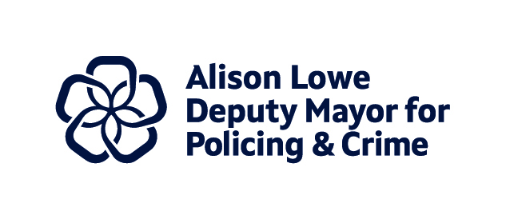
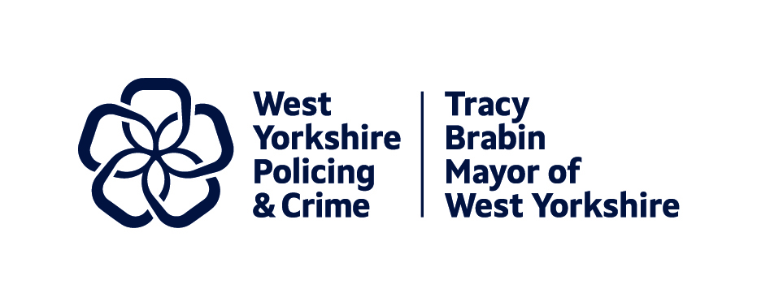
Item 7

Report to: | Police and Crime Panel
Date: | 07 March 2025
Subject: | Police and Crime Plan Priority One: Keeping People Safe
Report of: | Tracy Brabin, Mayor of West Yorkshire
Author: | Anna Scaife – Research and Performance Officer, Policing and Crime

- INTRODUCTION

  - This paper will explore the priority of keeping people safe. We will first look at why this is a priority as evidenced by the results of the Police and Crime Plan consultation and Needs Assessment, before outlining the work we will undertake to achieve this priority during the Mayor’s second term. The paper then details the activities of several workstreams since the Mayor was re-elected that fall under this priority. This includes several strategic actions such as the work of the Violence Reduction Partnership in tackling serious violence, work with West Yorkshire Police to reduce exploitation, driving the Safety of Women and Girls Strategy, and work to drive the outcomes in the Police Race Action Plan.

  - Why is this a priority?
- In the Police and Crime Plan Consultation , 95.7% of respondents described this priority as ‘important’ to them and 97% of partners also described this priority as ‘important’ to them.
- The top three areas of focus highlighted by the survey were knife crime, child sexual abuse / child sexual exploitation, and domestic abuse.
- The picture for knife crime in the Needs Assessment shows a long-term increase for knife enabled homicides and attempted homicides and a current short-term increase in knife enabled personal robberies. This will be considered as part of the new Serious Violence Strategy.
- Child sexual abuse is part of the Strategic Policing Requirement, and child safety and neglect is a top priority for partners within Child Safeguarding Boards in West Yorkshire. This topic links to our new cross cutting theme of Children and Young People.
- Domestic abuse is one of the main crime types for Violence against Women and Girls and is part of the national VAWG strategy.
  - What we will do:
- Work together on the Serious Violence Duty and co-produce the Serious Violence Strategy.
- Raise awareness of the tactics used by cyber criminals and work with WYP to reduce exploitation.
- Continue to drive the Safety of Women and Girls Strategy including the priorities of the Women’s Safety Unit.
- Work both locally and nationally to drive the outcomes in the Police Race Action Plan.

- Strategic Action 1: Work together on the Serious Violence Duty to co-produce the Serious Violence Strategy

  - This section of the paper outlines the work that has been carried out to work together on the Serious Violence Duty and co-produce the serious violence strategy, which is delivered by the Violence Reduction Partnership.
  - Serious Violence Duty
The Violence Reduction Partnership has developed a Serious Violence Duty partnership data dashboard – this draws together data from a range of partners including education, police, health, fire and the ambulance service for example to allow partners to self-serve on performance data needs and explore emerging issues using the dashboards tools.
We have also increased the number of data sharing agreements in place across the Serious Violence Duty partnership to provide additional information into the data dashboard and to inform the continued development of the Needs Assessment and Locality Profiles. A performance, research and analysis network for professionals across West Yorkshire from organisations designated as ‘Serious Violence Duty holders’ commences in March, chaired by the VRP Knowledge Hub lead. A Data Sharing Strategy has also been completed.

  - Working with district partners
The West Yorkshire Strategic Needs Assessment was drafted and published in January 2025 along with a refreshed partnership response strategy. The assessment works alongside the Influential Factors evidence synthesis which is an extensive report exploring the influential factors – both risk and protective - which can influence involvement in violence and or exploitation. Local profiles were also produced for each district.
Serious Violence Duty partners have been supported to develop (and implement) place-based Response Plans, responding to the Needs Assessment and Strategy through the driving of delivery at a local level managed by local governance arrangements and fed back into the Serious Violence Executive group.
Furthermore, since 2020 the VRP has worked collaboratively with the West Yorkshire Health and Care Partnership to co-lead a system wide programme focused on Adversity, Trauma and Resilience. The programme is facilitated by a governance structure that includes a West Yorkshire Strategy Group chaired by the Deputy Mayor for Policing and Crime, an Operational Network Group and workstreams focused on Staff Wellbeing and Trauma Informed Workforce Practice, Education, Criminal Justice and Reducing Violence Against Staff. More information can be found here.
  - Consultation and engagement
Extensive consultation and engagement has taken place across West Yorkshire to gain communities views of serious violence and suggested responses. Over 6000 people responded over the full exercise, contributing to our understanding of feelings of safety, perceptions of the causes of violence and services missing to tackle and prevent it. A series of reports have been compiled with the findings.
The VRP have also trained a number of Community Leaders across West Yorkshire. The Community Leader Programme is a leadership development Programme built for VRU’s, Police & Crime Commissioners and Local Authorities to offer local leaders, as part of a “whole systems / public health approach” to reducing violence and improving community safety. Following their expert review, the Community Leader Programme has been awarded ILM© recognised status. The programme aims to:
  - Provide community leaders with excellent leadership development
  - To improve relations between community groups and public officers
  - To refresh techniques to better engage communities and young people
  - To provide community leaders with operational expertise to help better manage initiatives to reduce factors that cause violence and build safer communities.
  - To create a network of community leaders who collaborate with each other and public agencies.

  - Supporting Young People in West Yorkshire

The partnership have supported the implementation of the Area Leader Pilot Project. Based in Bradford and funded by the Youth Endowment Fund, the pilot aims to increase evidence-based commissioning and the identification of children at risk of or involved in serious violence. Partners from across Bradford have come together to deliver sessions aimed at understanding what data different organisations hold, and how we can better utilise data sharing to ensure we are identifying the correct children. Additionally, looking at creating a process map to understand how a child at risk of or involved in serious violence, may progress through the system. As a partnership we will look at any barriers and enablers there may in the system and look at what interventions are available for these children.

In addition, following research and recommendations in 2023 by our youth commission, they have worked with the Violence Reduction Partnership and the communications agency ‘Resource Media’ to co-design a campaign to raise awareness on key issues such as attitudes and violence towards women, and drugs, gangs & knife crime. Some of the topics covered included image-based abuse, street harassment and public safety, spiking awareness and prevention, glamorisation of gangs and drug culture, knife crime and community fear, and exploitation of children and young people. The campaign goes live on 24th February 2025 at the VRP Showcase Event and the Launch of the Mayor’s new Police and Crime Plan for West Yorkshire.

A large number of programmes and interventions have been delivered across West Yorkshire, nine that have been commissioned directly by the Violence Reduction Partnership and a number of programmes commissioned locally across the 5 districts in accordance with their local profiles. The graphic in appendix A illustrates the reach of the delivery, with over 8000 children and young people engaged.

- Strategic Action 2: Raise awareness of the tactics used by cyber criminals and work with WYP to reduce exploitation.

  - This strategic action explores work carried out in collaboration with WYP to reduce exploitation which includes: modern slavery and human trafficking; child sexual exploitation and abuse; and cybercrime and combatting cyber criminals.

  - Modern Slavery and Human Trafficking

The Mayor supports cross-district collaboration on Modern Slavery and Human Trafficking (MSHT) through our co-ordination of the WY Anti-Slavery Partnership (WYASP). WYASP was established 10 years ago and continues to attract strong support from partners sharing the objectives of supporting victims and pursuing the perpetrators of modern slavery.

During 2024/25, WYASP has featured inputs from a range of agencies working to achieve these aims. The list includes; the Department of Work and Pensions, WY Trading Standards, Barnardo’s, the National Modern Slavery Helpline, Hope at Home, the Gangmasters and Labour Abuse Authority, Migration Yorkshire, the Medaille Trust, and the Salvation Army.

Looking back on the past year, the group has discussed concerns for exploitation of people working in the care sector. Post-Brexit, the use of sponsored visas to bring workers from India and African nations to the UK, has provided an opportunity for corrupt intermediaries. Visas are paid for in workers’ home nations, only for people to find on arrival here that the work is irregular or exploitative. The fear of losing the status of a sponsored worker also leaves migrants vulnerable to further exploitation under the threat of being reported to immigration authorities.

Partners across our local authority areas are working through their own modern slavery partnerships to raise awareness amongst migrant worker communities of how they can recognise and report cases of labour exploitation, as well as providing help to find legitimate employers for those who have been exploited.

Cuckooing is the manipulation of people in order to take control of their homes for criminal purposes. It is often linked to the supply of drugs and can include disturbing cases of the financial exploitation of people with specific vulnerabilities, such as disability, mental health concerns, old age, or substance dependency.

The police and social care services are working closely to develop strategies for enforcement in cases of cuckooing - helping to identify those individuals who are known exploiters, as well as helping to safeguard victims. In October’s WYASP meeting, we learned of the role the Dept. for Work and Pensions can play in helping to support vulnerable benefit recipients through their team of Advanced Customer Support Leaders.

In the year ahead, it is hoped that WYASP partners can collaborate to help the victims of modern slavery/human trafficking in the period when they are awaiting access to the National Referral Mechanism (the government’s programme of support for MSHT victims). At this time, potential MSHT victims are particularly vulnerable to being re-exploited. Reviewing the challenge of safeguarding victims within a limited supply of safe accommodation in West Yorkshire is an issue we hope to address with key partners in our network.

Please note the West Yorkshire Police awareness video on cuckooing, produced with support from the Mayor’s Safer Communities Fund: https://www.youtube.com/watch?v=SmMlcltegCE

  - Child Sexual Exploitation and Abuse (CSEA)
Our public consultation ahead of the new Police and Crime Plan has once again identified that CSEA is particularly important for local residents. At the start of 2025, the subject of ‘group-led’ sexual exploitation has been raised in Parliament, with the Home Secretary committing to a further report on this issue (following Prof. Alexis Jay’s ‘Independent Inquiry into Child Sexual Abuse’, 2022), and preliminary work in support of local area inquiries into non-recent CSEA (NRCSEA).
The Mayor has lent her support to WYP’s application for Home Office ‘Special Grant’ funding for extra resources to conduct NRCSEA operations during 25/26. This highly complex work has delivered important results for victims; WYP’s specialist teams have helped to convict over 200 suspects between 2015 and 2024, achieving custodial sentences totalling over 2,200 years (up to January 2025).
West Yorkshire’s child safeguarding partners are part of a new body established as part of the ‘Working Together’ framework published by the government in 2023. ‘Lead safeguarding partners’ who attend this meeting are the Chief Constable, West Yorkshire local authority Chief Executives, and the head of the NHS Integrated Commissioning Board. The first meeting took place in January, and through our usual governance arrangements with the Chief Constable, the DMPC will review the issues under discussion at this senior level meeting.
An example of the Mayor’s scrutiny of WYP’s work on child safeguarding can be found at our recent Community Outcomes Meeting.
  - Cyber Crime
Under the cycle of the new Police and Crime Plan, we intend to deepen our understanding of partners’ work to help to raise communities’ awareness of cybercrime, and the police’s work with national partners to target perpetrators. Since the Mayor was re-elected, West Yorkshire Police have continued to promote fraud prevention messaging over media platforms. Furthermore, the Economic Crime Unit (ECU) conduct awareness campaigns, with partners, to identify current threats and help promote information which will empower the public. This includes attendance at Leeds University Fresher’s week and shopping centres across the force to raise awareness close to Black Friday/Cyber Monday.
The ECU hosted a fraud crime prevention event at West Yorkshire Police Training and Development Centre on 28th September 2024. The event was supported by partner agencies such as WYP Cyber Team, Neighbourhood Watch, Victim Support, Fire Service and Age UK.
- Strategic Action 3: Continue to drive the Safety of Women and Girls Strategy including the priorities of the Women’s Safety Unit (WSU)

  - The team continues to drive the delivery of the Safety of Women and Girls Strategy through the themes of the strategy focusing on education, prevention, and tackling inappropriate behaviours. The team also assists the Women’s Safety Unit improve risk assessments, investigations and outcomes for women and girls. This section of the paper outlines what has been done to deliver this strategy and drive forward the work of the Women’s Safety Unit since the Mayor was re-elected.
  - The #JustDont campaign
The #JustDont campaign is continuing to achieve significant visibility and engagement in its efforts to combat everyday harassment and encourage men and boys to become allies in addressing gender-based violence.
The campaign video has garnered over 8 million views across all social media platforms since its release in September 2023. This level of engagement shows how widely the message has resonated across communities in West Yorkshire and beyond. A legal intellectual property license agreement has been established between West Yorkshire Combined Authority and other offices nationally to allow for asset sharing, and for other regions to use the campaign effectively to promote behaviour change. The campaign aims to normalise the expectation that men should stand up against inappropriate behaviour and harassment, rather than tolerate it. It helps create a culture shift by encouraging responsibility and proactive actions.
Through the campaign's visibility, it has sparked conversations about how men can actively participate in creating safer spaces for women and girls, making the issue of harassment more publicly acknowledged. Post campaign launch, HMP Wealstun wanted to understand how they could use this campaign to provoke peer-to-peer conversations, and influence behaviour change within the prison setting. HMP Wealstun is a Category C men's prison, located near the village of Thorp Arch in West Yorkshire, England. Each month HMP Wealstun plans an enrichment activity with their learners. The learning and education manager at Wealstun hosted #JustDont workshops, and will continue to do so, to understand what their views are. We will also be supporting them to embed this campaign in the prison induction system, and internal TV channel.
The #JustDont campaign is just one aspect of the larger strategy to improve safety for women and girls in West Yorkshire which is a continuation of the work undertaken in the Mayor’s first term, and its success in sparking dialogue and action represents an important step toward cultural change in the region.
  - Reclaim the Night
The Mayor and Deputy Mayor hosted their first Reclaim the Night event in Huddersfield’s Greenhead Park during October 2024, to empower women and girls to stand up for safer spaces as the evenings get darker during winter.
This was a crucial event for our region, as statistics show that 4 out of 5 women in the UK felt unsafe walking alone after dark in a park or open spaces (ONS, 2022) and the Mayor was keen to challenge that view, raise awareness of all the great initiatives, walking groups, and organisations such as classes that exist to empower women, funded by the Mayor’s Safer Communities Fund. The Mayor also wanted to maximise the learning and modifications that were made since the launch of the Safer Parks Research.
Over 300 people attended to the event and walk. The Mayor and Deputy Mayor were able to showcase innovations funded by the Mayor, such as self-defence classes, and the night-time safety bus in Kirklees, offering welfare and safety support for the night-time economy.
  - Safer Travel
The Mayor has been working with the wider Combined Authority transport teams and partners to develop best practice across staff to aid the personal safety of women and girls on the transport networks across West Yorkshire. For this reason, there have been significant developments for the Mayor’s Bus Safety Tool.
The Safer Travel PCSOs continue to reduce crime and anti-social behaviour, increase the safety of women and girls, and reassure and protect more vulnerable travel users. Data completed and filled in from the tool and survey is exported from the Combined Authority’s Research and Intelligence team to the Violence Reduction analysts, who now share that data to deploy officers across the bus network.
The tool footer, as demonstrated below, will be displayed in relevant sizes, inserted into the timetable production, eventually covering all 13,000+ bus stops in West Yorks including bus stations. The team in the Combined Authority are building in-app notifications feature on the MCard Mobile app this year, so we can include messages to highlight the existence of the tool. The plan is for the new timetable footer (see below) to first appear in a few weeks on some Arriva services that are being updated. From then on, the footer will be rolled out at all stops whenever timetables are amended.

  - The work of the Women’s Safety Unit
The Women’s Safety Unit (WSU) continue to lead on a number of themes, including:
    - Investigations and Risk Assessments
The WSU is leading extensive work with WYP and partners to transform the investigation of Rape and Serious Sexual Offences (RASSO) across the force and improve outcomes for victims. Whilst it will take some time to see the full impact on criminal justice outcomes (a rape investigation can take several months to reach this stage) progress in targeted tactical areas is already emerging. The WSU is driving ongoing improvements to investigation and prosecution processes through our new RASSO Tactical Plan and pioneering work with WYP and CPS.
- The number of Rape suspects referred to CPS for early advice or charging decision by WYP is increasing and is up by 16.4% compared to the same time the previous year
- Number of suspects authorised to be charged by the CPS has increased by 28.4% by similar comparison.
- An analysis of legal decisions taken by CPS is also showing as increasing. For those resulting in a charge the percentage is currently 71% compared to 60% a year ago. For those resulting in the CPS deciding not to prosecute, these have been falling and are currently at 29% compared to 40% in 2023.
- The outcome rate for Rape investigations has increased by 0.9%, which means that 63 more victims have received a positive outcome in the last 12 months up to September 2024.
- In the same time period, the positive outcome rate for Serious Sexual Offences has risen by 0.3% which means that 47 more victims received a positive outcome.
- The average time taken to charge a Rape offender has reduced by 7 days. Whilst this is a relatively minor reduction at this stage, it demonstrates the grass roots of progress in an area of key focus for the WSU, as we know that the length of an investigation is a key factor in both the victim’s wellbeing and the likelihood of them disengaging with the criminal justice process. Close strategic working with the CPS along with initiatives to improve file standards and utilise early strategy meetings are all underway to reduce this even further.

    - Domestic Abuse

Regarding Domestic Abuse, the WSU has been working with partner agencies to raise awareness of key tools to address offending and keep victims safe. Recent work with Leeds Domestic Violence Service led to national coverage that promoted the positive working relationship with WYP and the use of the Domestic Violence Disclosure Scheme in particular.

- Domestic Violence Disclosure Scheme (DVDS, also known as ‘Claire’s Law’) requests are the highest they have been since WYP started the scheme. Of particular note, ‘Right to Ask’ requests from victims and community members have increased by 38% in the last 12 months.
- The WSU is working hard to drive the use and enforcement of civil orders, by working with partners and internal colleagues to drive awareness through training packages and communications initiatives.
  - The use of Domestic Violence Protection Notice (DVPNs) by WYP is up by 1.6%. Again, whilst this is a modest rise, this represents a positive shift after months of declined use and reflects the increased emphasis on the use of such orders by the WSU and the wider WYP.
  - The number of Stalking Protection Orders (SPOs) acquired increased by 50% between 2023 and 2024 and this is expected to rise significantly given the number of SPOs under application (41 across 2024)

One specific initiative to improve outcomes and safeguarding of victims of Stalking and VAWG is the use of forensic marking. The WSU has been driving the use of SmartWater in VAWG investigations and the results are proving extremely positive.
For the SmartWater figures over the last 12 months we have protected 416 victims. From those surveyed:
- 88% would recommend
- 83% say it had a positive impact
- 74% feel safer
- 73% report no further perp contact
- 72% more trust in police
- 70% more confidence in police
- 56% report a decrease in incidents

WYP have had one conviction where forensic marking was introduced into the evidential chain in West Yorkshire, and in Derbyshire and Kent as other Forces nationally have followed our lead. The success to date has led to the Cabinet Office (What works VAWG) commissioning a formal evaluation of the work through the College of Policing. The findings of which should be released in April 2025.

    - Victim Support and Engagement

A key aim of the WSU is to enhance the support and service to victims of VAWG. The WSU has worked closely with the WYP Contact Centre to ensure the initial response to VAWG is enhanced, including bespoke training in Domestic Abuse and Homicide Timeline for staff, which has led to first hand feedback that staff are empowered and equipped to make improved risk assessment of incidents and better service to victims. Through liaison between the WSU and WYP victims will now be able to state gender preference of the attending officer and may have the option of speaking to a specially trained officer over video link to speed up attendance, capture evidence and provide an enhanced service to the victim.

The WSU has worked to capture the views and experiences of victim survivors through IAGs, Listening Circles and focus groups. The WSU has also commissioned audits of investigations to ensure victims are kept updated and all opportunities for safeguarding have been taken. All findings are fed into organisational learning for WYP to maintain victim focus. This has contributed to ever-improving victim satisfaction levels for victims of VAWG.

- Over 83.8% of domestic abuse victims surveyed respond that they are satisfied or very satisfied with the treatment they receive from West Yorkshire Police. 97.6% of victims report that officers treat them with respect, 96% report that officers listen to what victims have to say.
- The latest victim satisfaction results for the 12 months to Sept 2024 report overall victim satisfaction (for all surveys combined) at 72.8% whereas satisfaction reported by stalking victims is higher at 79.4% and 84.5% are satisfied with the outcome compared to 57.8% overall.
To further enhance the WYP service to victims the WSU is working with WYP to incorporate trauma-informed principles into training for Sexual Offence Liaison Officers (SOLOs), working with key partners from the VAWG sector to improve the training input and directly feed in the lived experiences and views of victims. The WSU is supporting WYP in ensuring that all front-line officers and staff will be trained in ‘RASSO – First Responder’ by the end of the year. This far surpasses national expectations and demonstrates the reach and influence of the WSU to put VAWG and victims at the forefront of police activity.
The WSU leads community engagement on a wide range of VAWG topics. The team led a highly successful VAWG week of action, focusing on Spiking and the nighttime economy. This resulted in;
- communications assets featuring in prominent locations, buses, hospital waiting rooms and social media,
- over 180 arrests for VAWG offences,
- over 100 visits to licensed premises to check on responses to women’s safety
- the deployment of ‘Op Spotlight’ to identify dangerous and predatory behaviour in the NTE.

- Strategic Action 4: Work both locally and nationally to drive the outcomes in the Police Race Action Plan.

  - This final section explores work carried out across the districts since the mayor was re-elected to drive the outcomes of the Police Race Action Plan, which includes engagement and promotion of the plan, in addition targeting hate crime and encouraging community cohesion.

  - West Yorkshire context: Hate Crime and Incident Data

From December 2023 to November 2024, 9,579 hate incidents were reported to West Yorkshire Police which is a decrease on the previous 12 months, when 9,668 hate incidents were recorded. This is eighty-nine less reports that equates to a -0.9% decrease.

In the last twelve months 195 were non crime related and 9,384 were crime related compared to the previous 12 months, when 166 were non crime related and 9,502 were crime related (Please note, the data set does not equal the total of overall figure. This is due to crime recording anomalies and classification requirements.)

Hate incidents can be categorised across the strands of race, faith, disability, sexual orientation, and transphobia. The number of hate crimes recorded in the 12 months to November 2024 have decreased by -3.2% from the previous 12 months. However, the recent increases in 2024 are predominantly associated with the ongoing conflict in Gaza. This is believed to be the case due to the sharp increase in reporting of anti-Muslim and anti-Semitic incidents at the start of the conflict and the continued reports throughout the following months alongside the decrease in reports from other strands. Increases can also be attributed to the recent national anti-immigration protests.

The National Community Tensions Team collate data of initial reporting of hate incidents. The last report highlighted the seasonal trends in hate crime across the UK (Excluding Scotland). In most cases, strands follow a similar annual pattern with increases in reporting during the summer months. This report noted that in 2023, overall hate crime was comparable to the previous year. However, the overall stabilisation was offset by a significant increase in faith hate crime and stated that it is certainly due to the conflict between Israel and Hamas. Whilst decreasing from its peak in October 2023, it is highly unlikely to return to pre-7th October levels for the first half of 2024.

  - Promotion of the Police Race Action Plan
Across the districts, activities have taken place to promote the implementation of the Police Race Action Plan. In Calderdale, during Hate Crime Awareness week (October 2024), Hate Crime Coordinators completed nine contact point/stalls across the District in partnership with the Local Authority and local NPT teams. They also attended a Gypsy and Travellers meeting and implemented “Cuppa with a Coppa” to raise awareness of hate crime reporting and to promote their approach to the Police Race Action Plan.
In Wakefield, a community forum was held to promote the Police Race Action plan and to encourage open discussions with members of the Black community on the issues they face, and any recommendations or advice they can provide to improve our processes and relations. Additionally, during Islamophobia Month officers presented at the Abubaker Mosque to encourage Hate Crime reporting, offer support, and promote the Police Race Action Plan. Officers also deployed the Community Engagement Van to two high schools to promote hate awareness and the Police Race Action Plan. The events were attended by over three hundred children at both sites.
In relation to stop and search, work continues to deliver teaching on effective communication during a stop and search encounter on the Foundation Training Course delivered by specialist officers. This means that all new police officers now receive this input as part of their initial police training. The content highlights the importance of effectively engaging with those who officers may be thinking about searching under stop and search powers, explaining the reasons for the stop, actively listening to the person who has been stopped and if the decision to search that person is made, then a full explanation of the grounds and the process utilising the GOWISELY DEC model. GOWISLEY DEC is a mnemonic developed to aide officers when conducting stop and search to ensure compliance with Code A of PACE. The E in DEC refers to ethnicity where the officer should ask and record the self-defined ethnicity. More information can be read here.
Officers continue to attend the mandatory 2-day Cultural Awareness training module in which they are given inputs into the effects of Police stop and search on our black communities. To date, 4549 officers and staff have successfully completed this training.
All stop and search encounters of the black community members are reviewed at Sergeant and Inspector level to ensure a robust and thorough scrutiny process in this area. This is monitored by Local Policing to ensure further checks and consideration for further referral to the force scrutiny panels.
More detail on numbers of stop and search and use of force can be found in the new performance framework for the Police and Crime Plan launching this year.

CONTACT INFORMATION

Contact Officer: | Anna Scaife - Research and Performance Officer, Policing and Crime
E-mail: | Anna.scaife@westyorks-ca.gov.uk

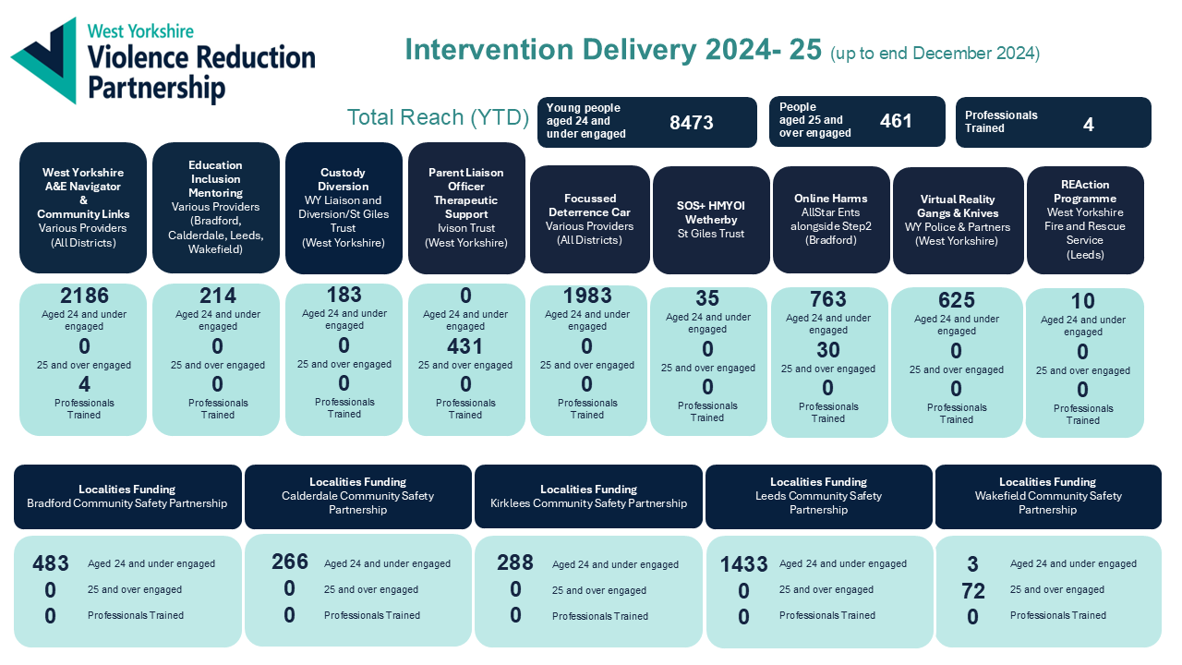
Appendix A

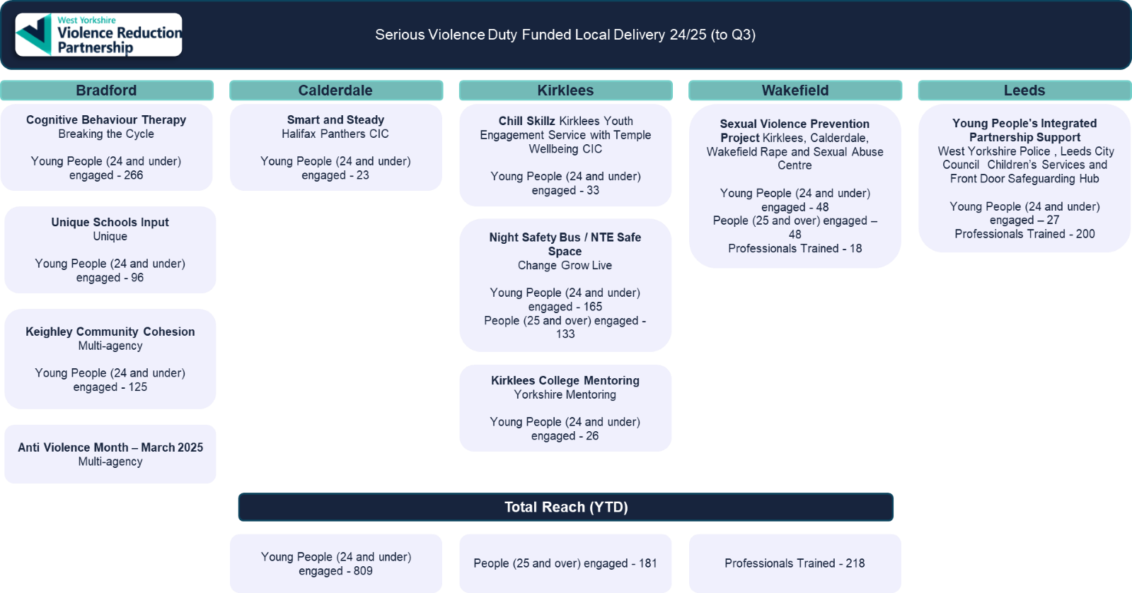

Violence Reduction Partnership document repository West Yorkshire Combined Authority
Youth Commission research - leaders-unlocked-final-report.pdf
Rolling 12-month data Q2 2023 vs Q2 2024 - https://criminal-justice-delivery-data-dashboards.justice.gov.uk/ Criminal Justice Delivery Dashboards, published on 12th December ‘24
https://criminal-justice-delivery-data-dashboards.justice.gov.uk/ Criminal Justice Delivery Dashboards, published on 12th December ‘24
Source: Criminal justice system overview - CJS Dashboard. 380 days on average. July 23 to June 24
See Voices Project – Engaging Survivors to Create Change - LDVS
Source: Clare’s Law - Domestic Violence Disclosure Scheme | West Yorkshire Police. 2504 right to ask requests in 2024, compared to 1811 in 2023
Source: WYP internal data as of 16/01/25. 378 in last 12 months, compared to 372 in previous.
Source: WYP internal data, provided by N. Pringle, Safeguarding Governance Unit. 9 in 2023, 14 in 2024.

