MAYOR FOR WEST YORKSHIRE
RESPONSE TO THE POLICE AND CRIME PANEL

I would like to thank the members of the Police and Crime Panel for their careful consideration of my precept proposal on 6 February 2026 and for endorsing a 5.7% increase. This decision enables us to continue investing in the future of policing and community safety across West Yorkshire.
This proposal was supported by 57% of respondents to my public survey. The increase represents an additional £15 per year for Band D households, with the majority of Council Taxpayers paying less than 29 pence more per week.

As part of its approval, the Panel has sought assurance on the following commitments:
- Report back to Panel with regular information on the Community Safety Fund budget and grants position, and work with local authorities to address risks to funding for schemes.
- Work with West Yorkshire Police to retain and increase the numbers of PCSO’s where funding allows, and continue to lobby at a national level for greater local flexibility in decisions relating to the recruitment of police officers, staff, and PCSOs.
- To report back mid-year on the reserves position providing assurances that these are maintained at a sustainable level and reduce the reliance on reserves going forward.
- Work to further increase the diversity of respondents to the 2027/28 online budget consultation, and maintain the level of diversity for the in-person consultations, providing Panel with comparisons for previous years to enable the tracking of improvement. In addition, work with Panel members and relevant partners to start pre-engagement work before the official start of the consultation period.
I am pleased to confirm my commitment to:
- Provide the Panel with updates on the Community Safety Fund through the regular Police and Crime Plan Priority reports, which include information on activities and associated expenditure aligned to each priority.
- Work with West Yorkshire Police to retain and increase the numbers of PCSO’s where funding allows, and continue to lobby at a national level for greater local flexibility in decisions relating to the recruitment of police officers, staff, and PCSOs.
- To report back mid-year on the reserves position providing assurances that these are maintained at a sustainable level, following our finance team’s mid-year report.
- Seek to further broaden the diversity of respondents to the 2027/28 online budget consultation through approaches such as targeted social media advertising and organic engagement, including sharing content with community groups, where budget and resourcing allow. We will also make efforts to maintain the current level of diversity within the in-person consultation sessions, again subject to available budget and resourcing. Next year’s report will also include information on comparison with previous years, and we will seek to work with panel members and partners ahead of the official start of the consultation period.

In the interests of transparency and accountability, I wish to record that a clerical, de minimis error was identified in an aggregated total within the documentation provided to the Panel and in the original precept notices. The discrepancy arose from a transposition error in the council tax base figure for Calderdale, resulting in the summary table at paragraph 14.1 showing a total precept of £195.3m (£195,265,686.29) instead of the correct £195.4m (£195,432,653.15). This variance, approximately 0.085% and less than 0.03% of the police budget, has no effect on the Band D amount, the Panel’s unanimous decision or the validity or operation of the precept. Corrected notices have been issued to all billing authorities and West Yorkshire Police has been informed. Therefore, I would be grateful if the Panel could note this correction at its next meeting to ensure accuracy of the public record.

Notwithstanding the correction above and given the Panel’s support for the proposed precept, I confirm my approval of a Band D annual precept of £278.28, which is a £15 increase equating to 5.7%.
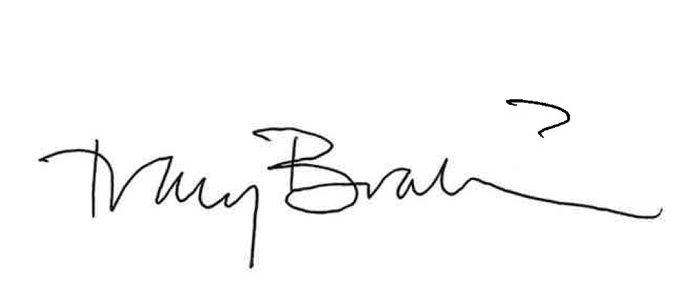

Tracy Brabin
Mayor of West Yorkshire

