Appendix A
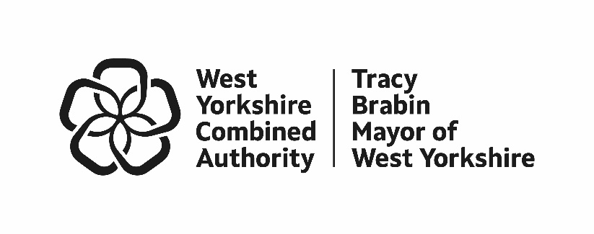
Police Precept Consultation Results 2026/27 Budget

The following summarises the findings from our 2026/27 Police Precept Consultation, which included both an online and in-person survey that enabled us to answer questions, gather feedback, and engage in open discussions about police funding.
- Background
  - The precept consultation ran from 19th December 2025 to 21st January 2026. The online survey closed on the 20th January, and the in-person consultation finished on the 21st January to maximise engagement opportunities. Like previous years, we waited until the precept cap was announced by the government before launching the survey so we could go to the public with an accurate picture of the costs associated with the proposed increase.

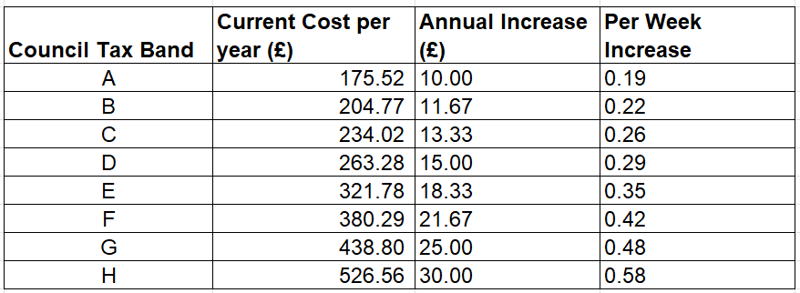
  - Residents were asked to share their views on the proposed £15 annual increase for Band D households, equivalent to 29 pence per week. Respondents were provided with the table below so they could understand the weekly cost for the different Council Tax bands.

- Methodology

  - West Yorkshire has a population of approximately 2.35 million. To ensure a confidence interval of 99%, with a 5% margin of error, we needed a sample size of 666 respondents or more to get a representative result. However, we were keen to far exceed the 666 figure and ensure that every effort was made to make the consultation and engagement work as inclusive as possible within the timeframe provided, reaffirming the Mayor’s commitment to diverse responses and an inclusive process.

  - Prior to the launch of our online and in-person work, we held a focus group with 10 people on 12th December 2025 to review the content of the survey including the introductory narrative, suggested questions and supporting display boards. Their feedback informed the survey and supporting materials. Key points included:
- Understanding the need for the increase in precept
- Clarity around West Yorkshire Police Spending
- Simplifying our messaging
- Placement and phrasing of free text options
- Question order

  - The online survey was hosted on the Combined Authority ‘Your Voice’ webpage and promoted from 19th December throughout the festive period and in January.
  - During the in-person consultation (w/c 9th January – 21st January), once again we prioritised engagement in shopping centres and bus stations across West Yorkshire. These locations consistently generate the highest footfall, enabling us to speak directly with members of the public about the police precept. The consultation in the form of an in-person survey reflected the same ask as the online survey allowing us for the first time to compare online and in-person results and the impact of the precept consultation as a whole.

  - Large display boards showing police income and spend and the suggested increase across Bands A to H were used generate a thorough conversation in shopping centres in Bradford, Calderdale and Leeds and in bus stations in Wakefield and Huddersfield. Attendance times were broadly centred around 1000 – 1600 in the day and at weekends to maximise opportunities.

  - As in previous years, the focus of the in-person work has been to reach those people who will not or cannot complete the online survey. To ensure the survey gaps were identified in real time, the team reviewed all data on a weekly basis and monitored online numbers daily. This provided additional objectives for our in-person work informing district locations, gender and the age groups of those we needed to speak to in-person. For example, at the outset of the consultation the aim was to speak to at least 500 people (100 per district) which was based on a similar response rate to the online survey last year. However, when the online survey exceeded last year’s response rate, we recognised a need to increase the number of residents we engaged with for the in-person work, to ensure any gaps did not increase. As with all our consultation and engagement, the aim was to ensure our in-person work was as inclusive as possible.

  - On 19th January the team also held an online session hosted by Alison Lowe, Deputy Mayor for Policing and Crime. This gave us the opportunity for residents to ask more detailed questions around police funding and the precept proposal. 10 people attended with 90% supporting the increase.

  - At a scheduled Serious Violence Co-production event on 21st January, we also asked attendees to complete the survey. 42 people responded and their results are included in the 912 people reached via our in-person work.

  - Finally, in a bid to increase district representation in Calderdale a further in-person event was organised, but this proved unsuccessful due to short notice. Learning from this year will inform the methodology for 2027.

- Survey Promotion
  - The consultation was widely promoted through targeted social media advertising to encourage responses from underrepresented groups, via the Combined Authority’s ‘Your Voice’ platform, and through our network of partners across West Yorkshire to broaden its reach. The following section details the activities that were undertaken during the consultation timeframe.

  - Media

19/12 – Press release issued to local media and placed on the website Have your say on the police budget in West Yorkshire
Coverage secured in Wakefield Express, BBC, Telegraph & Argus, Yorkshire Evening Post (print and online), MSN UK Lifestyle, Kirklees Local TV, Keighley News, BBC Radio Leeds.

06/01- BBC Message the Mayor- The Police precept was discussed as a theme with the Mayor of West Yorkshire Tracy Brabin, during the hour-long session on BBC Radio Leeds.

  - Internal activities

19/12 Leaflet with QR code linking to survey created for the engagement team to support their work in-person.

19/12 Email signature created for WYCA colleagues and circulated

10/10 Worked with the Design team to create printed boards to support the engagement team with their in-person work.

08/01 WYCA Intranet item published with link to survey. (This received 295 views)

12/09 Shared on internal weekly briefings

  - Partners

07/01 Intranet item sent to West Yorkshire Police for publication and sharing across their networks. Also requested use on publicly automated systems and to be shared across their EDI networks. Over the period of the consultation, the news item was given a “hero” spot on their intranet front page with a total of 1225 page views.

06/01 Circulated it to all Local Authority Head of Communications to share widely internally and with partner networks. Content also provided for external use (Wakefield Council confirmed they’d include it across internal/ external channels, including the Your District newsletter).

09/01 - Item on precept survey included in a newsletter sent to Women of West Yorkshire Network members (now over 1,000), which included a tailored video message from the Deputy Mayor.

15/01 - Circulated to West Yorkshire town and parish councils asking them to share to their networks.

16/01- Provided a social media post to the West Yorkshire Police and Crime Panel for further circulation across their channels/ networks.

  - Social Media

Organic social media activity

19/12 - Post on Deputy Mayoral channels. Reached 1,700, 73 click throughs on Facebook. Also shared on X and LinkedIn.

5/01 post – Post on Deputy Mayoral channels. Reached 25,231, 269 click throughs on Facebook. Also shared on X and LinkedIn.

7/01 post – Video post on Mayor’s social channels. Reach 3,024 with 147 engagements.

7-8/01 – Facebook posts containing a link to the survey shared in community groups (initial shares in early Jan, over the course of the consultation, posts continued to be accepted into groups). Total reach was to 74.5k members in geographic groups. Full list: Police precept comms - Facebook groups .docx

9/01 - Video posted from our Bradford engagement event with the Deputy Mayor promoting the consultation. Reached 3,900.

15/01 - Post promoting the online in-person consultation event- reached 300.

19/01 - Post promoting the online in-person consultation event- reached 1,620.

Paid social media advertising

The campaign ran between 7th-20th January 2026. Overall, the campaign was highly successful in achieving its primary objective, contributing to a 264% increase in survey completions during the campaign period. It also met its secondary objectives by broadening demographic representation. Female participation increased, responses were evenly distributed across areas, ethnic diversity improved modestly and the proportion of older respondents decreased, resulting in a more balanced respondent profile.

Compared to 2025, the 2026 campaign outperformed for a marginal increase in spend, delivering 74% more impressions, doubling survey completions (2,582 vs 1,290) and reducing cost per click.

  - Community alerts

19/12 - 11,813 emails distributed, 5,386 read which led to 393 link clicks

05/01 - 11,908 emails distributed, 5,084 read which led to 402 link clicks

12/01 – 11938 emails distributed, 5,474 read which led to 341 links clicked

16/01 - 11,952 emails distributed, 5,502 read which led to 87 links clicked *please note this was to promote the in-person and online event, as well as the online survey
- Survey Results
  - 3,474 residents responded to the consultation. 2,562 of the responses were generated from the online survey and 912 came from in-person consultation.
Residents were asked:
Whether they support the proposal to increase the Council Tax police precept with the opportunity to feedback on the proposal and make any other comments about funding the police service in West Yorkshire.
  - Headline results
- 57% of respondents supported the proposal to increase the Council Tax police precept.
- 52% of online respondents supported the proposal to increase the Council Tax police precept, compared to 71% of respondents for the in-person survey. These results have been combined to produce a headline figure of 57% support.
- 76% of respondents were from Band A to D households, with Band A households the most frequent (23% of the total).

 | Yes | No | Respondents
Q1. Do you support the proposal to increase the Council Tax police precept? | 57% | 43% | 3,444

Q: Respondents'  Council Tax Band | % of all respondents | No. of respondents | % supporting precept increase
A | 23% | 804 | 58%
B | 16% | 545 | 57%
C | 18% | 626 | 59%
D | 18% | 620 | 56%
E | 8% | 264 | 52%
F | 4% | 151 | 53%
G | 2% | 61 | 61%
H | <1% | 11 | 55%
Don't know / not specified | 11% | 362 | 52%
Total | 100% | 3,444 | 57%

- Results by Demographic
  - The following section looks at the different survey types and the results by demographic so that we can understand the results in more detail.
  - District
The charts below outline who responded to the survey by district and what proportion of those in each district supported an increase to the council tax police precept. We have separated the results into three charts that show the online results, in-person results and the combined survey results.
Most respondents were from Leeds when looking at the combined result (32%). This is also the case for the online survey (33%) but for the in-person work, most respondents were from Kirklees (28.9%). When looking at the combined result, those from Calderdale were the most supportive of the proposal to increase the council tax police precept whilst Bradford was the least.

  - Age
The pie charts below show the respondents by age group for the online, in-person and combined survey results. When looking at the combined results, over half of respondents were aged 55 and over. 51% of respondents to the in-person survey were 54 and under compared to 42% of online respondents.

  - Gender Identity
The pie charts below show respondents by gender identity for the online, in-person and combined survey results. The combined result shows that the number of men and women who responded to the survey was roughly equal. The online survey attracted more male respondents (51%) however the in-person work was able to generate engagement with more female respondents (63%).

  - Ethnicity
The pie charts below show respondents by ethnicity for the online, in-person and combined survey results. Overall, the combined result shows that the vast majority of those who responded to the survey were white (81%). The online survey struggled to attract respondents from ethnic minority backgrounds and 7% of those who completed the online survey were non-white. The in-person work sought to bridge this gap and 23% of those we engaged with were non-white. This has resulted in 10% of those who completed the consultation being non-white when looking at the combined result.

  - Disability or health condition status
The pie charts below show respondents by disability or health condition status for the online, in-person and combined survey results. When looking at the combined results 28% of respondents considered themselves to have a disability or health condition. The proportion of respondents was greater for the in-person work at 33%, compared to 26% of those who answered the online survey.

- Survey Results Analysis

  - Regarding the combined results, those in the Council Tax brackets A, C and G were the most supportive of the increase to the council tax police precept. The combined results show that residents from Calderdale were the most supportive of the increase and those from Bradford were the least.

If we look at the combined results, the responses received are broadly proportionate to the district-level population profile of West Yorkshire (Bradford and Leeds are slightly underrepresented whilst Wakefield is overrepresented). The in-person survey saw a high number of respondents from Kirklees.

  - The combined results show that women were more supportive of the proposal than men. 63% of women showed support compared to 56% of men. Those 55 and over were most supportive of the increase to the council tax police precept (60%) compared to 35 - 54-year-olds who were the least supportive (55%). 59% of those aged 34 and under supported the proposed increase.

  - Regarding the combined results, 61% of white respondents were supportive of the proposal to increase the council tax police precept compared to 51% of non-white respondents. Those who did not consider themselves to have a disability or health condition were more supportive of the proposal compared to those who did (60% compared to 57% respectively).

  - We acknowledge that those who responded to the online survey are not reflective of the different ethnicities that make up West Yorkshire. The in-person engagement sought to bridge this gap and 23% of all those we spoke to face-to-face identified as from an ethnic minority group.

- Free Text Comments

  - There were two free text opportunities throughout the survey so respondents could explain the reasons for their answers. This included space for residents to share any comments or feedback they wanted to make about the proposal as well as further comments about funding the police service in West Yorkshire.
Across both questions online and in-person we received 3,967 comments. This included 3176 comments online and 791 in-person.

  - Online Comments
Officer visibility- The most frequent feedback we received from the online survey were comments around officer visibility and issues around police presence (530 comments). Many of these comments related to not seeing officers in their neighbourhood or how the presence of officers would act as a deterrent, particularly for neighbourhood crime. It’s worth noting that there were a lot of comments where residents highlighted that they supported the proposal but would like to see more officers in their area as a result.
Funding and support- The second most common theme in the feedback we received related to support for increased funding (474). Some of these comments cited positive personal experiences with the police as their reason for support, whilst others highlighted high local crime levels and the associated pressure on existing resources. There were also a number of comments where respondents said that they support the proposal with the caveat that services improve.
Lack of trust and confidence in the police- The third most frequent piece of feedback related to a lack of trust and confidence in the police, whether that be due to a prior bad experience or a poor perception of West Yorkshire Police performance (430 comments). Some of these comments also highlighted a perception of higher crime rates in their area and apathy around reporting crime.

  - In-person comments
Funding and support- Of note the large display boards containing information about the precept proposal, police income and what the money was spent on (Figure 1) most definitely generated additional free text comments around cost and spending with 98 people expressing their views in general terms around how underfunded they believed West Yorkshire Police was. The comments were predominantly sympathetic to the challenges of modern policing and there seemed to be a real understanding of the impact of cuts to policing.
Officer visibility- The second highest frequency of free text comments (88) related to police officer visibility with many responding citing locations or crime types that could be better supported with visible policing. Most people said they would be more reassured if they saw more officers on the streets.
Affordability- 79 comments related to residents stating they could not afford to pay the increase at all or would struggle to pay it, with minimal numbers saying they simply did not want to pay it. Some people felt it was unfair or unjustified for the level of service they received. There was a strong view that the police should be better funded through central government, and some concerns shared around what funds were spent on or how West Yorkshire Police is managed and resourced.
Positive attitudes towards west Yorkshire Police- Across the in-person work, noting 71% were in support of the proposal, most people qualified this view with personal examples which included:
- Positive responses and actions taken by West Yorkshire police/behaviour or service from individual officers in response to incidents and crimes including how they had dealt victims of crime.
- There were also general positive comments including those around trust and confidence in policing as well as a real recognition of the need for policing. Respondents expressed concerns about reduced officer numbers and emphasised that the service provided by the police is essential to ensuring safety for themselves, their families, and the wider community.
- Many people also supported Police funding in general terms with people stating they would pay even more for policing if they could.
Lack of support for the proposal- Those who chose not to support the proposal (29%) mostly did so based on negative views towards policing and personal experiences of what they viewed as poor attitudes, behaviour or performance. Some people spoke about the level of antisocial behaviour (ASB) and drug related crime, with the need for the police to do more. A small number of people also expressed the concern of being over or unfairly policed.
Looking at both positive and negative responses, areas where people wanted to see more/better policing were related to serious violence including gang crime, knife crime, violence against women and girls, ASB and road safety. Below are some examples of key quotes which reflect the feedback.

  - Comments for and against supporting the proposal

‘I live in one district but work in another, as a Doctor I work late on a night, I know we need to pay more so that policing can be focussed on high crime areas, and I understand this might not be where I live but I want to feel safe where I work as well as where I live’

‘The police do a great job, I work in a shop in the bus station, and we often get a lot of bother, the local NPT check in frequently and the police come when we need them’

‘I am a stalking victim, the police did a great job in gathering the evidence, its going through the courts now so I support the police’

‘I live in a high crime area, so we see them all the time even in the early hours, so I support the increase’

‘We need the Police, wages haven’t gone up to compensate for the increase - but we need bobbies on the beat’

‘I own a business, and I had £50,000 worth of stuff stolen from my garage. The police offered me an online meeting, I wasn’t very happy’

‘I had an issue with drug dealers. I reported it, but the police did not do much’

‘I don’t support it, but we will have to pay it anyway’

‘We are ex police officers, but I am not sure we would support. We still have friends in the police’
- Reflections on the in-person Consultation
  - The in-person consultation offered a great opportunity to talk to residents about police funding. We have consulted nearly twice as many people this year (912) than in 2025 (502) and spoke to people from every council tax band. Some people were still surprised to learn about the police precept element of their Council Tax. Many respondents were unsure of their council tax band, so we verified this information for them to ensure their responses corresponded accurately with the proposed increase.
  - Last year, 51% of those we spoke to supported the increase compared to 71% this year. As stated, views were influenced by their personal experiences and positive contact with the police, their knowledge about police funding issues and finally their recognition that they needed to maintain policing services to keep them safe. Whilst there was some apathy and a view that residents would have to pay the increased precept whatever the cost, most of the people we spoke to welcomed the opportunity to be better informed and to take part in the consultation.
  - As with all our consultations we spoke to many people who did not wish to complete a survey but offered further feedback on the Council Tax, Local Authority Spending, West Yorkshire Police and the Combined Authority. As well as the table shown at section 1.2 of this report, the below information (figure 1) was also provided on a large display board to support our in-person consultation.
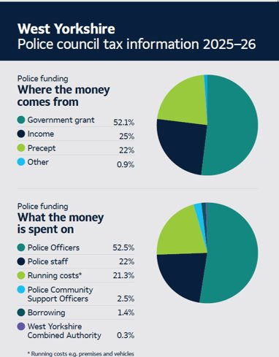
Figure 1

