Report to: | Police and Crime Panel
Date: | 17.07.2026
Subject: | Police and Crime Plan Priority Three: Supporting Victims and Witnesses
Report of: | Alison Lowe, Deputy Mayor of West Yorkshire
Author: | Policy Team Policing and Crime – West Yorkshire Combined Authority

- Police and Crime Plan Performance Measures – Priority Three Overview (Supporting Victims and Witnesses).
  - The below overview should be considered alongside the Performance Matrix which gives the detail for the individual measures of the Police and Crime Plan. The summary below focuses on metrics relating to Priority Three in the Plan which is Supporting Victims and Witnesses.
  - The Performance matrix was developed in themes rather than linking performance measures to priorities, with the understanding that many performance measures span more than one priority. The below is therefore a look at the measures that mostly speak to priority three.

- Confidence and Satisfaction
  - Overall confidence in local police is the measure that is usually quoted from the Crime Survey of England and Wales (CSEW) data. West Yorkshire is around 3% lower than the Most Similar Group (MSG) average standing at 67.8% and has declined since the previous quarter.
  - Regarding agreement that the police can be relied on when needed, West Yorkshire stands slightly above the MSG average at 52.1% and this is a consistent and steady trend. Agreement that the police would treat you with respect is 0.1% above the MSG average at 82.5% despite a slight downturn in the most recent quarter.
  - In relation to Victim Satisfaction, 72.1% of the 10,142 victims interviewed in the 12 months to March 2026 were satisfied with the overall service received – 1.8% reduction.
  - In terms of satisfaction for different stages of the contact process with the police, ‘Ease of Contact’ and ‘CSI Investigation’ are both showing increased levels of satisfaction at 91.1% and 92.6% respectively. ‘Treatment’, ‘Actions Taken’ and ‘Remote Investigation’ are all showing decreased satisfaction, however 9 in 10 people are still satisfied with ‘Treatment’.
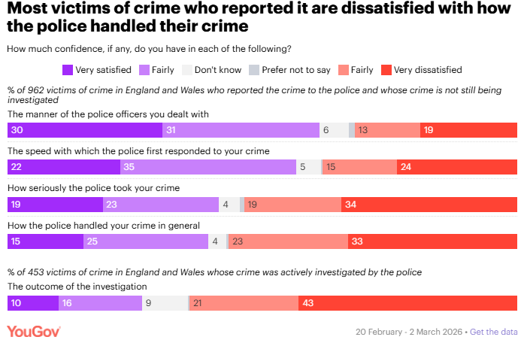
  - When looking at the national context, the YouGov survey published in March 2026 provides some additional insight. This survey shows that nationally, most victims of crime who reported it were dissatisfied with how the police handled their crime.

  - The interim results of the ‘Your Views’ newly commissioned survey can be seen in the community measures section of the performance matrix. We will soon receive the Q4 results which we will use as a baseline going forward. In future iterations of the performance matrix, we will compare and contrast this with the national figures from the CSEW to better understand the position in West Yorkshire
  - With regard to response to incidents, West Yorkshire is currently on a reducing trend with emergency incidents at 80.9% attended in the target time (compared to 83.4% during the previous 12 months). However, there has been an increase in the number of priority incidents attended on target at 68.6% compared to 67.7% in the previous 12 months.
  - West Yorkshire Police did have all domestic incidents classed as priority incidents and this increase in number is evident from February 2025 on the corresponding chart, but due to the negative effect on response, this pilot was withdrawn. We have seen the number of priority incidents drop and stabilise, with the number of those attended on target increasing.

- Supporting Victims
  - The total number of overall VAWG offences has seen a slight decrease across all categories during the last quarter (rape, stalking and harassment and other sexual offences). However, numbers are still up significantly in the last 12 months compared to the baseline reporting period (by 21.9%).
  - Domestic occurrences had been on the increase since the end of last year however, the most recent quarter has seen a decrease and numbers appear to be stabilising.
  - In relation to hate crime, there has been a 6.3% decrease in the 12 months to March 2026 when compared to the same period last year. We will continue to monitor performance data throughout the next quarter to assess whether increased community tensions have had any impact on crimes here in West Yorkshire given some national media reports of a rise in hate crime against certain communities.
  - The number of missing child occurrences has increased substantially since the last quarter which could be attributed to seasonal fluctuations; however, we will monitor this figure closely.

- Investigations
  - The number of positive outcome rates for VAWG offences has been on a steady increase since August 2025 and continues to rise during the most recent quarter across rape, other sexual offences and stalking and harassment.
  - In other good news, the monthly Domestic Violence Protection Notice (DVPN), Domestic Violence Protection Order (DVPO) and Claire’s Law count numbers are all on an increasing trend (although the Claire’s Law count looks to have plateaued). This is encouraging, as it reflects increased use of preventative and safeguarding measures to protect victims and those at risk of domestic abuse.
  - When looking at the criminal justice measures, West Yorkshire does not compare favourably when looking at the other MSG forces in relation to the average number of days taken for the police to charge an offender in all victim-based cases which stands at 36 days. However, we are performing better than the national average which stands at 40 days. Despite this performance for all victims of crime, in West Yorkshire the number of days it takes to investigate Rape and Serious Sexual offences specifically has reduced by 40%.
  - Regarding the number of cases stopped after a defendant has been charged because a victim no longer supports or is unable to support the prosecution, West Yorkshire benchmarks positively against other MSG groups with a figure of 17%, which is still 1% higher than the national rate. But recent figures to the Local Criminal Justice Board shows that the number of cases stopped before a defendant has been charged (i.e. whilst the investigation is ongoing) due to the victim no longer supporting is much lower in West Yorkshire than elsewhere ( 20% in West Yorkshire vs 26% national rate)
  - For more information on all of the Criminal Justice Measures please see the Criminal Justice Scorecards on the gov.uk website Chart builder - CJS Dashboard

For more information contact
Wendy Stevens – Research and Performance Manager
wendy.stevens@westyorks-ca.gov.uk
Anna Scaife- Research and Performance Officer
Anna.scaife@westyorks-ca.gov.uk

Appendix 1 – P&CP – Performance Framework

