

**PROGRESS REVIEW:**

**THE POLICE AND CRIME PLAN**

**A CONSULTATION**

*MARK BURNS-WILLIAMSON*

*POLICE AND CRIME COMMISSIONER FOR WEST YORKSHIRE*

CLOSING DATE: SUNDAY 24 NOVEMBER 2013

|  |
| --- |
| **FOREWORD** |

On 27 March 2013 I launched the Police and Crime Plan 2013-2018 setting the strategic direction for policing and community safety across West Yorkshire for the next five years.

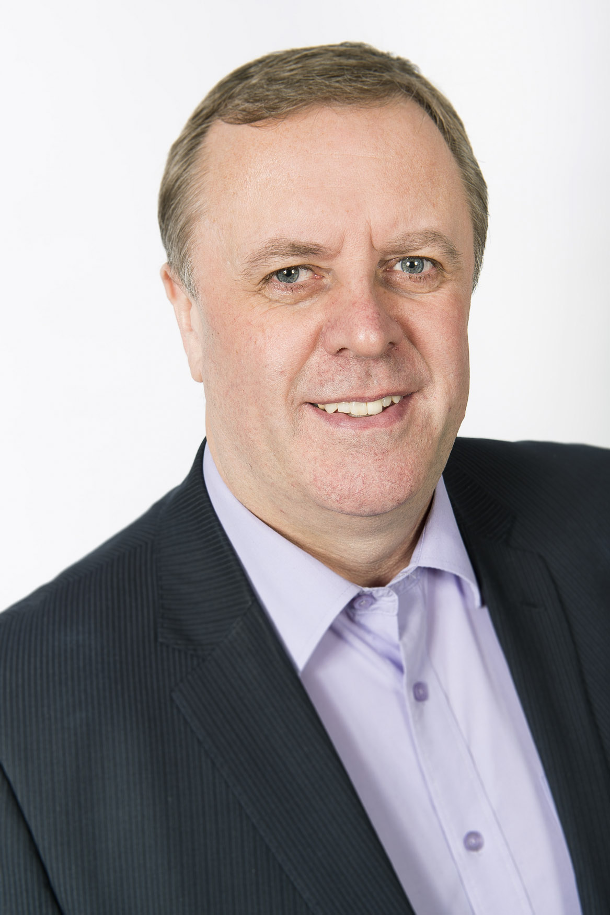

In the first week of taking office I launched a ‘Listening to You First’ consultation engaging with over 2,100 individuals and hundreds of organisations across the county to make sure that the priorities I set out in the Police and Crime Plan addressed the needs and concerns of stakeholders and partners.

The plan sets out the community outcomes that I agreed with local partner organisations. I firmly believe that working together, in partnership, is the way to make sure we make real change for the better. Commitments in the Plan are being met but the priorities set out cannot be delivered by West Yorkshire Police alone – partners are key to ensuring that communities are safer and feel safer.

I made a pledge to review my plan on an annual basis. It is over six months since it was launched and this is an opportune time to consider how the Plan is currently working. Do you feel the priorities are relevant, are there any gaps, how can I better consult with stakeholders in the future and have your priorities or the needs of your organisation changed? I must be clear that the outcomes will not change – it is the priorities and commitments that are up for review.

I have produced this consultation document for feedback on the current plan so that I may assess its usefulness and any changes needed. I have aimed this stage of the consultation at stakeholders and partners, by this I mean local councils, community safety organisations, businesses, trade unions, charities, volunteers and other community organisations that tackle crime and community safety problems locally, regionally or nationally. I intend to hold stakeholder roundtable events to discuss your priorities in addition to this consultation document. However I will be consulting separately with the wider community and absolutely welcome the views of any individual who wants to express an opinion about the current plan and its relevance to them.

I look forward to receiving your responses, and hope that together we can continue to make communities safer and feel safer.

Best regards



Mark Burns-Williamson OBE

|  |
| --- |
| **INTRODUCTION** |

Set out below are a number of questions that I would like you to answer. If you do not have a copy of the Police and Crime Plan to hand, a copy of the Executive Summary is appended to this consultation document. Alternatively you can download a copy of the plan from my website [www.westyorkshire-pcc.gov.uk](http://www.westyorkshire-pcc.gov.uk)

|  |
| --- |
| **1. ASSESSMENT OF EXISTING PRIORITIES** |

The priorities within the plan were informed by a needs assessment that considered a range of information including crime trends, partner priorities, public opinion, national crime priorities and a wealth of thematic policies and strategies. Please let me know your thoughts on the current priorities and any gaps that you feel exist.

For each of the below priorities please indicate whether this is a priority for you/your organisation or not.

|  |  |  |  |  |
| --- | --- | --- | --- | --- |
| **1A. COMMUNITIES ARE SAFER AND FEEL SAFER** | **This is a priority for me** | **It is generally a priority but the focus could be improved** | **This is not a priority for me** | **This should not be included in the Plan** |
| Working together |  |  |  |  |
| Preventing crime |  |  |  |  |
| Reducing burglary |  |  |  |  |
| Tackling hate crime |  |  |  |  |
| Protecting people from violent and serious crimes |  |  |  |  |
| Preventing attacks on workers |  |  |  |  |
| Reducing re-offending |  |  |  |  |
| Young people contributing to society and playing by the rules |  |  |  |  |
| Recognising business crime |  |  |  |  |
| Reports of anti-social behaviour will be responded to in a way that victims and communities are happy with |  |  |  |  |
| Look at new anti-social behaviour powers |  |  |  |  |
| The quality of support provided to victims will improve and I will listen to the concerns of victims and witnesses |  |  |  |  |

|  |  |  |  |  |
| --- | --- | --- | --- | --- |
|  | **This is a priority for me** | **It is generally a priority but the focus could be improved** | **This is not a priority for me** | **This should not be included in the Plan** |
| Support use of victims getting justice by those who commit crimes agreeing to put right what they have done |  |  |  |  |
| Tackling and treating drug and alcohol addiction |  |  |  |  |
| Reaching out to people with mental health issues, missing and vulnerable people |  |  |  |  |
| Fighting serious and major crime |  |  |  |  |
| Collaborating and delivering in partnership |  |  |  |  |
| Responding to national threats |  |  |  |  |
| Creating confidence |  |  |  |  |
| Ensuring integrity |  |  |  |  |
| I will listen to and be accountable to the public, including young people and minority groups |  |  |  |  |
| Commitment to neighbourhood/local policing |  |  |  |  |
| Securing more funding/income streams |  |  |  |  |
| Retaining more money gained from criminals through Proceeds of Crime |  |  |  |  |

|  |
| --- |
| **For those where you feel the focus could be improved, could you tell me how it could be improved** *(please state clearly which priority you are referring to)***.** |

|  |
| --- |
| **1B. Are there any priorities that aren’t currently included in the plan that you would like to see included in future?** *For any new priorities please provide information to evidence why you think they should be included.* |

|  |
| --- |
| **2. DELIVERY OF THE PRIORITIES AND COMMITMENT STATEMENTS** |

Delivery of many of the outcomes, priorities and commitments (see Executive Summary for examples of commitment statements) cannot be achieved without more integrated partnership working. Please could you let me know how you/your organisation have used the plan, and how you can help to achieve the commitments I have set out.

|  |
| --- |
| **2A. How have you actively used the Plan?** |

|  |
| --- |
| **2B. Which commitment statements within the Plan do you feel you can help/have helped to deliver?** |

|  |
| --- |
| **2C. For those commitments stated in 2B, how could you help to deliver these?** |

|  |
| --- |
| **2D. Are there any commitments that you disagree with? If so, why?** |

|  |
| --- |
| **2E. Are there any commitments you would like me to make that aren’t already included?** |

|  |
| --- |
| **3. FORMAT AND USABILITY OF THE POLICE AND CRIME PLAN** |

The plan was written and formatted in a way that was intended to be user friendly. My intention was that it was an accessible document and useful to multiple audiences.

Please answer question 3A based on the full version of the Police and Crime Plan.

|  |  |  |  |  |
| --- | --- | --- | --- | --- |
| **3A. HOW MUCH DO YOU AGREE WITH THE FOLLOWING STATEMENTS?** | **Strongly agree** | **Tend to agree** | **Tend to disagree** | **Disagree strongly** |
| The plan is easy to read |  |  |  |  |
| The layout is easy to follow |  |  |  |  |
| I understand what the PCC and partners are trying to achieve |  |  |  |  |
| The plan contains the right balance of text and pictures |  |  |  |  |
| The plan contains too much information |  |  |  |  |
| The plan does not contain enough information |  |  |  |  |
| The content is relevant |  |  |  |  |
| The performance measures contained in the plan are not useful or relevant |  |  |  |  |

|  |  |  |  |  |  |
| --- | --- | --- | --- | --- | --- |
| **3B. HOW USEFUL DO YOU FIND…?** | **Very useful** | **Fairly useful** | **Not very useful** | **Not useful at all** | **Not aware** |
| The full Police and Crime Plan |  |  |  |  |  |
| The executive summary |  |  |  |  |  |
| The local district plan |  |  |  |  |  |

|  |
| --- |
| **3C. For those versions of the plan that you have not found useful, why is this?** |

|  |
| --- |
| **3D. If you could change two things about the plan what would they be?**  1.  2. |

|  |
| --- |
| **4. CONSULTING ON MY PLAN** |

Before producing my Police and Crime Plan I undertook a series of consultation exercises to ensure that partner and community priorities were properly reflected within the plan. Please could you let me know how you engaged in the consultation process – if at all – and how you would like to be consulted with in the future.

|  |  |  |
| --- | --- | --- |
| **4A. WHICH OF THE FOLLOWING WAYS DID YOU ENGAGE WITH THE PCC?** | **Yes** | **No** |
| I spoke to the PCC during his election campaign |  |  |
| I met directly with the PCC after his election |  |  |
| I took part in a public consultation event arranged by the PCC or his office |  |  |
| I took part in a stakeholder consultation event arranged by the PCC or his office |  |  |
| I sent information (via post or email) on my priorities directly to the PCC |  |  |
| I fed information directly to my local community safety partnership |  |  |
| I completed a Listening to You First survey |  |  |
| I completed another survey relating to crime, policing or community safety |  |  |

|  |
| --- |
| **4B. What is the best way to work with you to annually refresh the plan and take into account your issues/priorities?** |

|  |
| --- |
| **5. COMMUNICATION OF THE POLICE AND CRIME PLAN** |

I would like to communicate this plan as widely as possible, so that as many people can be involved as I can reach and do this without spending a lot of money. I would be interested to get your feedback and ideas on the communication of the plan.

*For questions 5A-C please select all those options that apply.*

|  |  |  |  |  |  |  |  |
| --- | --- | --- | --- | --- | --- | --- | --- |
| **5A. COMMUNICATION** | **Email** | **Post** | **Media coverage** | **Word of mouth** | **Visit from the PCC** | **Other** | **Not aware of the launch** |
| How did you hear about the launch of the Police and Crime Plan? |  |  |  |  |  |  |  |

|  |  |  |  |  |  |  |
| --- | --- | --- | --- | --- | --- | --- |
| **5B. RECEIPT OF THE PLAN** | **Post** | **Email** | **Website** | **Meeting with the PCC** | **Other** | **Never seen the plan** |
| How did you obtain a copy of the plan? |  |  |  |  |  |  |

|  |  |  |  |  |
| --- | --- | --- | --- | --- |
| **5C. FUTURE RECEIPT** | **Post** | **Email** | **Website** | **Other** |
| How would you like to receive the plan in future? |  |  |  |  |

|  |
| --- |
| **5D. How could the priorities within the plan best be communicated to the public more widely?** |

|  |
| --- |
| **6. GENERAL COMMENTS** |

|  |
| --- |
| **6A. Are there any other comments you would like to make with regard to the existing Police and Crime Plan?** |

|  |
| --- |
| **7. ADDITIONAL INFORMATION** |

Could you please provide some information about yourself so that I know who has completed the feedback.

|  |  |
| --- | --- |
| **Organisation:** |  |
| **Contact name:** |  |
| **Position:** |  |
| **Email address:** |  |
| **Date of completion:** |  |

|  |  |  |
| --- | --- | --- |
| **Would you be happy for me to add your contact details on to my database, which will be used to keep you informed about policing updates, details of events or for other consultation exercises?** | **Yes** | **No** |
|  |  |

**Ploughland House, 62 George Street, Wakefield, WF1 1DL**

**Telephone: 01924 294000 Email:** [**contact@westyorkshire-pcc.gov.uk**](mailto:contact@westyorkshire-pcc.gov.uk)

***To find out more about the commitments I have made in my plan please visit*** [***www.westyorkshire-pcc.gov.uk***](http://www.westyorkshire-pcc.gov.uk)

**Crime and re-offending is reduced**

* I want **domestic burglary in West Yorkshire to be reduced.** I have set the police and partners a target for performance to be better than the most similar forces and partnerships in England and Wales.
* I will use my position as elected representative to bring people together with partners to tackle all forms of **hate crime**.
* To tackle **domestic violence** I will work with partners to encourage people suffering from domestic abuse to come forward and report what is happening to them, provide the support they need to feel safe and stay safe and explore new ways to better tackle it.
* I will work with partners to make children, wherever they are, safer from those who exploit vulnerable young people, identifying and punishing those in groups and gangs **sexually exploiting children.**
* I will work with trade unions, business people and other relevant partners in West Yorkshire to ensure that **people at work** are and feel protected.
* I will work with communities and organisations such as schools and the voluntary sector to open up **opportunities for young people** that will put them on a path away from anti-social behaviour or crime.
* Agree a definition for **business crime** and make sure that I consult with local businesses in a way that is meaningful and useful.

**Communities in West Yorkshire are safer and feel safer**

If crime, re-offending and anti-social behaviour are reduced, victims and witnesses feel supported. If local, regional and national threats, risks and harm are tackled and partners work together in an efficient and effective way, then communities become and feel safer. Strong, cohesive communities are important for wellbeing, for our quality of life, and for people to feel included.

* Making sure that communities are safer and feel safer is not just the responsibility of the police but is everyone’s business. I am committed to working in partnership with you, local councils, community safety organisations, criminal justice agencies, businesses, trade unions, charities, volunteers and other organisations in your communities to tackle the problems which matter on your street, across West Yorkshire and nationally.
* I will ensure that **crime prevention** is at the forefront of efforts to reduce the opportunity for acquisitive crime (such as burglary and car crime), violent crime, business crime and anti-social behaviour.

**What can we achieve together?**

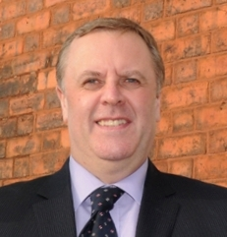

Welcome to a summary of the first Police and Crime Plan for West Yorkshire. As your newly elected Police and Crime Commissioner I have produced a plan to set out a strategic vision for policing, both tackling and preventing crime in our county over the next five years. The plan can be found on my website at www.westyorkshire-pcc.gov.uk

People living, working and volunteering across West Yorkshire know what we need to do together to achieve community cohesion and build community safety and the plan has been produced in partnership around shared outcomes and ambitions.

Together we will make our communities safer and feel safer.



Mark Burns-Williamson OBE

**West Yorkshire**

**Police and Crime Plan 2013-2018**

**Executive summary**

**Communities are listened to**

* I will spend as much of my time as possible listening to the people of West Yorkshire, visiting neighbourhoods, holding surgeries and listening to a wide range of groups about their experiences and what matters to them.
* I have made five promises to young people. I will work with partners and **young people** to see how I can fulfil these promises, which are to:
  + Make myself accessible to young people and provide appropriate ways for young people to express their concerns to me (e.g. face-to-face surgeries, social media, e-petitions).
  + Treat all young people as citizens, valuing their interests and opinions as much as any other group in the community.
  + Provide an equal platform for all members of the community, including minorities and those who are marginalised.
  + Establish a way of meaningful representation of young people’s views by creating, for example a young advisory panel.
  + Use my influence as Police and Crime Commissioner to support the police to engage positively with all young people.

**Criminal justice system is effective and efficient**

* I will work in partnership with **criminal justice agencies** to achieve the outcomes people expect for their communities particularly for victims of crime.
* With the police I will ensure **stop and search activity** is used appropriately, proportionately and when necessary to do so, working with communities to assess the impact this activity has had on them and better explain why.
* I will scrutinise complaints against the police and, wherever possible, aim to help put things right. I will actively engage in the consultation around how complaints are dealt with independently, in a national body or otherwise. I will set up an independent review of **police conduct and standards**.

**Local, regional and national threats, risks and harm are tackled**

* I will work with partners to get a better understanding of the serious problems that exist in our communities around **drugs and alcohol** and work towards reducing the harm caused to individuals, families and communities through the abuse of drugs and alcohol.
* I will work with partners to improve our understanding of the issues around **mental health,** community safety and the criminal justice system and put in place better systems to deal with those issues.
* I will work with the police and other agencies to ensure the threats posed locally and nationally by **organised crime groups** are tackled in the most effective and efficient way to minimise serious harm in our communities.
* I will make sure that we have the right resources and people to **tackle national threats** such as terrorism, serious public disorder, organised crime, major cyber incidents and civil emergencies.

**Victims and witnesses are supported**

* I have made five promises to **victims and witnesses**. I will work with partners to see how we can fulfil these promises to:
  + Be open and accountable to victims and witnesses, seeking out and acting on their views.
  + Make sure victims and witnesses get the high quality help and support they need, when they need it.
  + Make the police more victim focused and be more effective in meeting victims’ needs.
  + Give victims and witnesses an effective voice in the wider criminal justice system.
  + Constantly work to develop new ways of delivering justice for victims.

**Anti-social behaviour is reduced**

* Reports of anti-social behaviour will be responded to in a way that victims and communities are happy with.
* I will identify the best way to check that services provided in communities to tackle **anti-social behaviour** are dealing with the problem in the right way at the right time when people need them.